Nebraska NEBP Eclipse Experience
Kendra Sibbernsenª

Abstract
As a part of the engineering track of the Nationwide Eclipse Ballooning Program (NEBP)¹ for Nebraska, our team had planned for the total solar eclipse for two years. The students took a class at Metropolitan Community College to learn the basics of high altitude ballooning. The team did troubleshooting and bench testing, had several practice launches, and had an incredibly successful flight streaming video for the duration of the annular eclipse in Roswell, NM on Oct. 14, 2023². For the total solar eclipse, we were hosted by the Southern Illinois University in Carbondale, Illinois. The team had an ambitious agenda and launched three balloons prior to the eclipse and recovered all three balloons³. For totality, the launch team stayed at the school in Oak Ridge, Missouri, the base station team was located on the roof of the physics building in Carbondale, Illinois, and the recovery team stopped at a quiet park in Mount Vernon, Indiana. Results from the scientific experimental payloads will be presented.

Ballooning | Eclipse | Nebraska | ...

- Introduction
The Nebraska Nationwide Eclipse Ballooning Project (NEBP) team was comprised of members from three institutions: Metropolitan Community College (MCC), the University of Nebraska – Lincoln (UNL) and the University of Nebraska – Omaha (UNO). Michael and Kendra Sibbernsen (MCC and Branched Oak Observatory) participated in the NASA Eclipse Ballooning Project for the total eclipse in 2017 and were the co-leads for this project. Derrick Nero was the mentor at UNO and Karen Stelling was the mentor at UNL. Although it was a challenge to manage a project this large with this many students over multiple institutions, the interaction of the mentors and students made this possible.

Kendra Sibbernsen developed an online class for students to prepare for the NEBP to run at MCC over three quarters in 2023. A NASA Nebraska Mini-Grant was awarded to pay for the tuition for all students who participated. Students were recruited from all three participating institutions and 20 students enrolled in the community college classes. The four mentors attended an NEBP workshop in Minneapolis, Minnesota in May of 2023 and the hands-on building of the video streaming equipment and additional student payloads took place over the summer and fall of 2023.

- Annular Eclipse Experience

A team of 14 students and mentors drove from Lincoln, NE to Roswell, NM for the annular eclipse on October 14, 2023.

Early on Saturday morning, the Launch Team went to Hondo High School, 47 miles West of Roswell, New Mexico, while the Ground Station Team stayed in town at University High School. Two other NEBP teams (Virginia Tech. and Missouri S & T) were launching from the same location (Fig. 1).

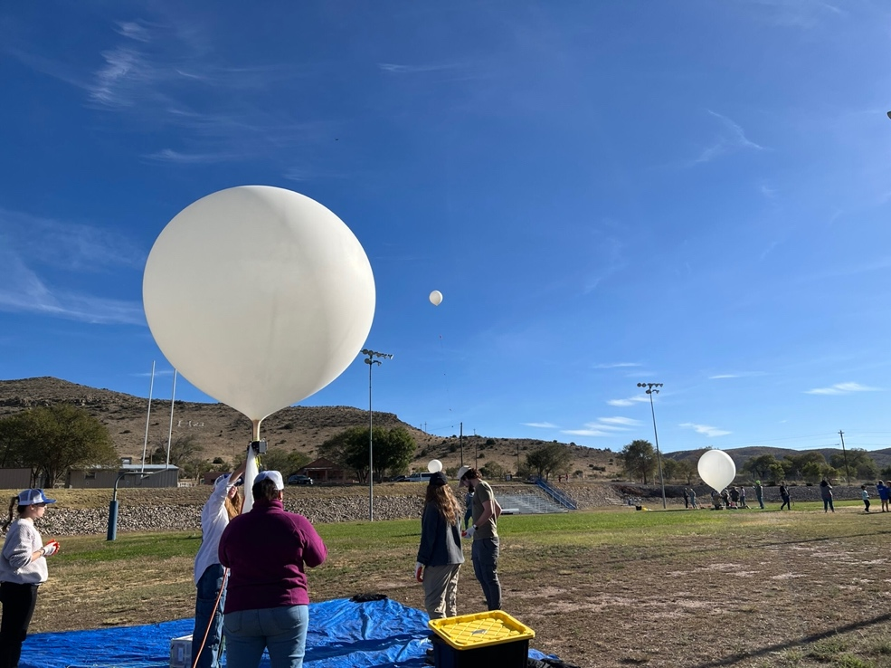
Figure 1

The balloon was filled and was on schedule to launch at 9:30am. The balloon was mostly filled when it separated from the vent, leaving the payloads behind. Surprised, but undaunted, the team quickly removed their second balloon, and started to fill with their back-up helium reserve. Launching a little late, but within an acceptable window, the balloon started its journey to the stratosphere.

On the way back to Roswell to drop off the helium cylinders, the launch team stopped to enjoy the annular eclipse (Fig. 2 and Fig. 3).
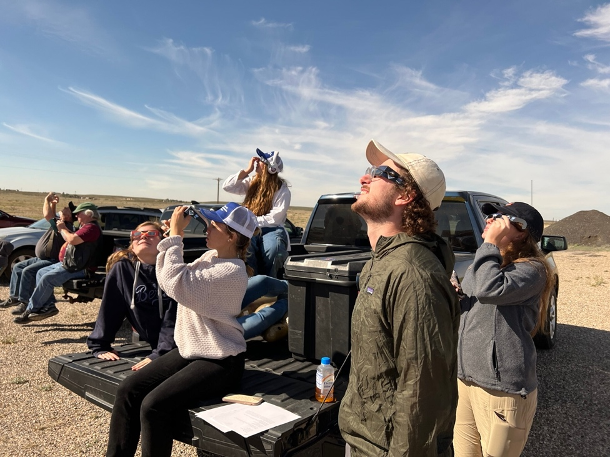
Figure 2

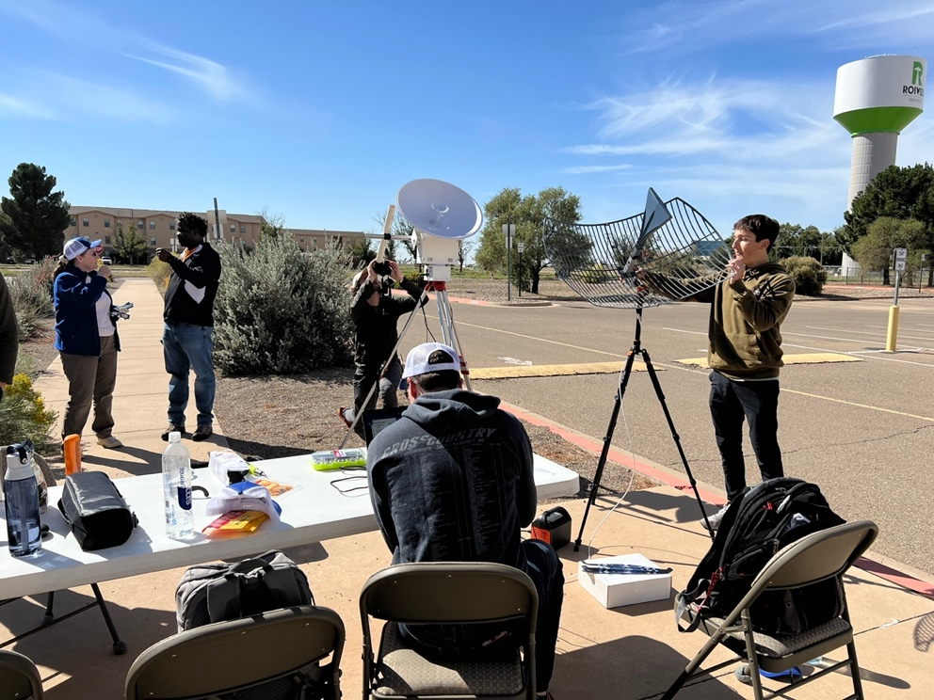
Figure 3

All of our systems were functional while in the air, if not perfectly. This includes the PTERODACTYL, Iridium, RFD900, 360 and Go-Pro camera systems, as well as the video streaming. We were able to live-stream our video through most of the flight from the balloon to YouTube, even if it was a little choppy, had some cut-outs, and the parachute obscured the view part of the time. This was the most successful attempt of the entire system in flight that we had.

The venting system was successfully activated around 60,000 feet, and took 20,000 additional feet to slow the ascent. The maximum altitude reached by the balloon was 81,138 feet. After the eclipse path had passed, a cut-down signal was sent, but the system did not cut. The Chase Team followed the balloon 138 miles, drifting much further than anticipated. It turns out that the balloon never released and simply continued to vent until it lost altitude. When the recovery team discovered the payloads, the balloon was still intact (Fig. 4).

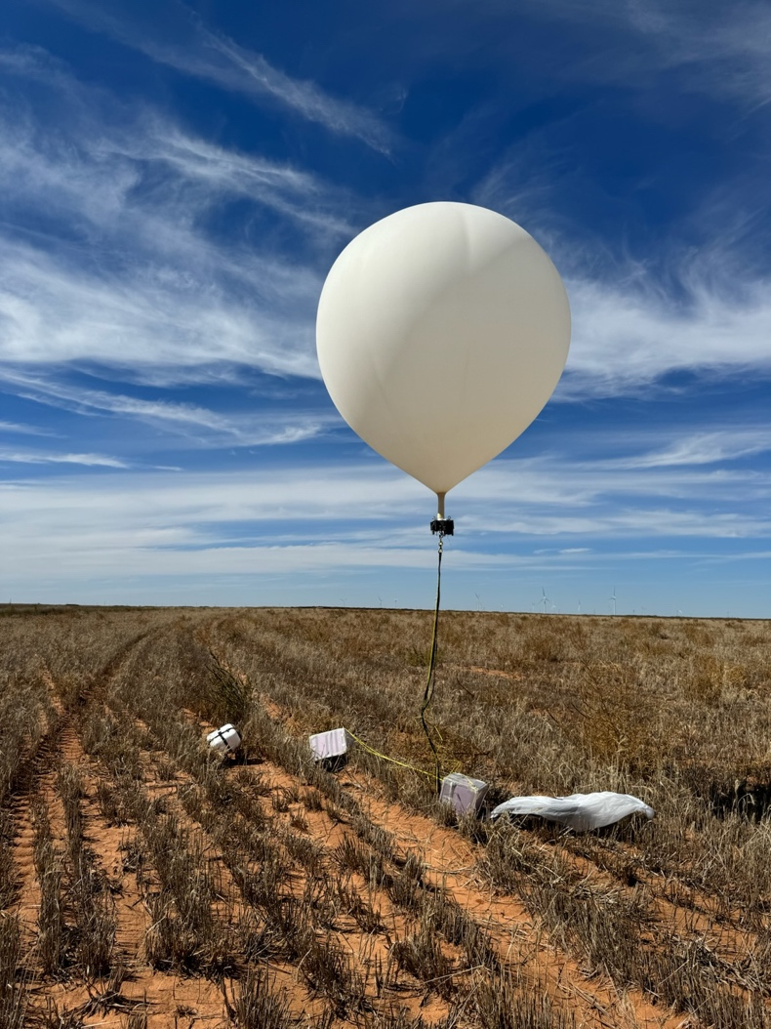
Figure 4

- Total Eclipse Experience

For the total solar eclipse on April 8, 2024, the Nebraska team included 13 students and mentors traveling to Carbondale, Illinois to be in the path of totality. Our team was hosted by the Southern Illinois University (SIU) in Carbondale, called the “Eclipse Crossroad of America” because they experienced totality in 2017 as well as this year.

Our base station team was located on the roof of the physics building (Neckers Hall). This was near the stadium which had a huge local event on the day of the eclipse. Two other NEBP engineering teams were also located there (the Iowa State team and the University of Hartford). This provided an opportunity for valuable interaction and collaboration between the teams.

While the students were in the lab working on Sunday, Michael Sibbernsen was invited to Banterra Center Arena to present at the Crossroads Astronomy Science Technology Expo as a part of our outreach component for the project. Speakers from organizations from all over the country (including the Air Force, Johns Hopkins University, NASA Goddard Space Flight Center, and The Adler Planetarium) gave a variety of Astronomy and Eclipse-related programs. Michael presented his “Beyond the Shadow” program, and was pleased to have a crowd of over 250 people in attendance (and over a thousand in the background within earshot.) (Fig. 5)

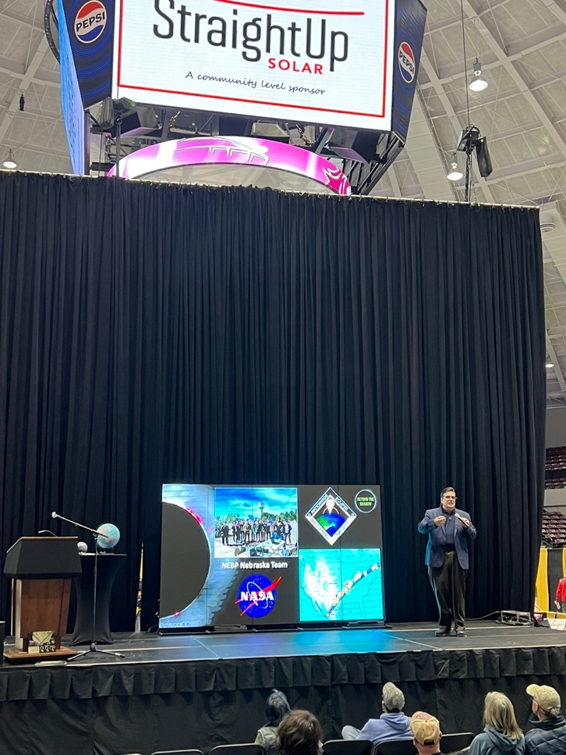
Figure 5

The day before the eclipse, Derrick Nero (UNO) and Enrico Obst (University of Hartford) took a scouting team on Sunday and found an ideal location for launch at Oak Ridge, Missouri at the high school, an hour southwest of Carbondale. They gained permission from the superintendent to set up there. That location was chosen because, after analyzing the flight prediction, our intention was that our balloons would be near Carbondale at altitude to minimize the distance to our streaming base stations. It was a perfect choice because the University of Hartford’s NEBP balloon was only 5 miles from the SIU campus as it passed overhead.

The Nebraska team had an ambitious agenda by launching three high altitude balloons back-to-back-to-back to release within a half hour time frame. This was a record for the number of balloons launched by a single team for all of us. (Fig. 6)

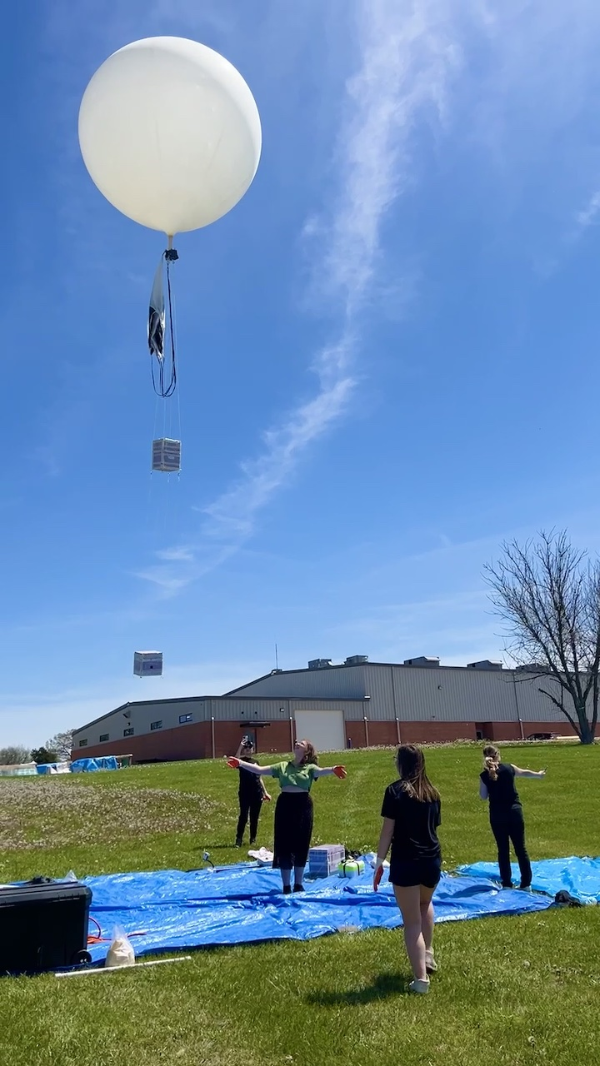
Figure 6

We had three forms of tracking on each balloon and all of that tracking equipment was working well. This is a screenshot of the Montana State University Borealis site used for tracking all of the NEBP balloons. On the day of the eclipse, all of the balloons were lined up along the path of totality. (Fig. 7)

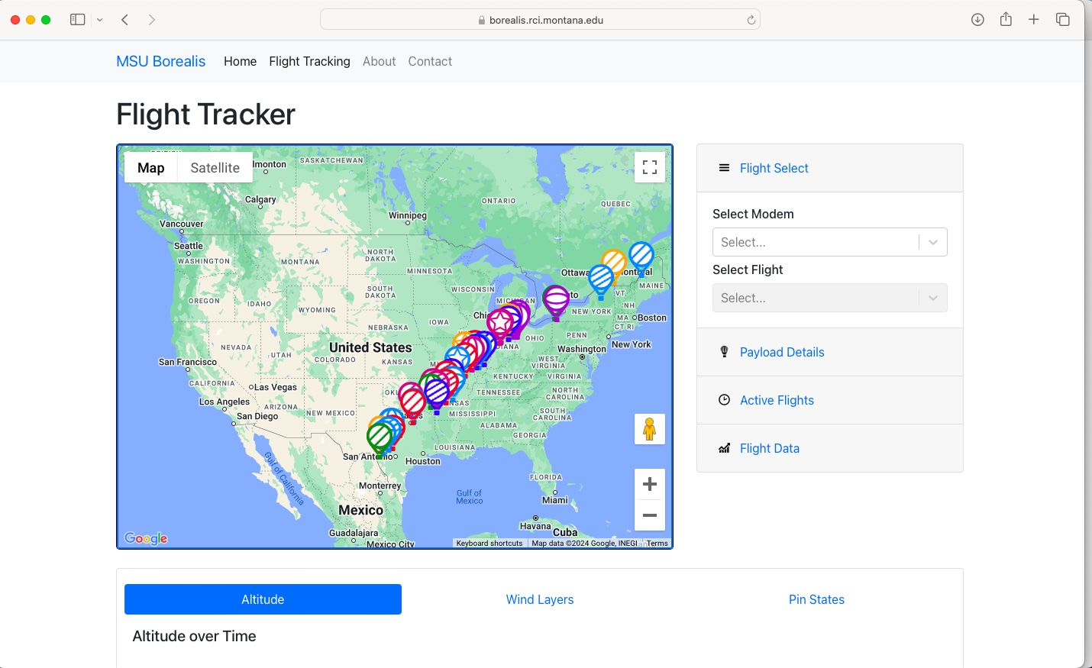
Figure 7

For totality, the launch team stayed at the school in Oak Ridge, Missouri, the base station team was located on the roof of the physics building in Carbondale, Illinois, and the recovery team stopped at a quiet park in Mount Vernon, Indiana.
We all had clear views of the eclipse and it was an amazing experience for everyone involved. (Fig. 8)

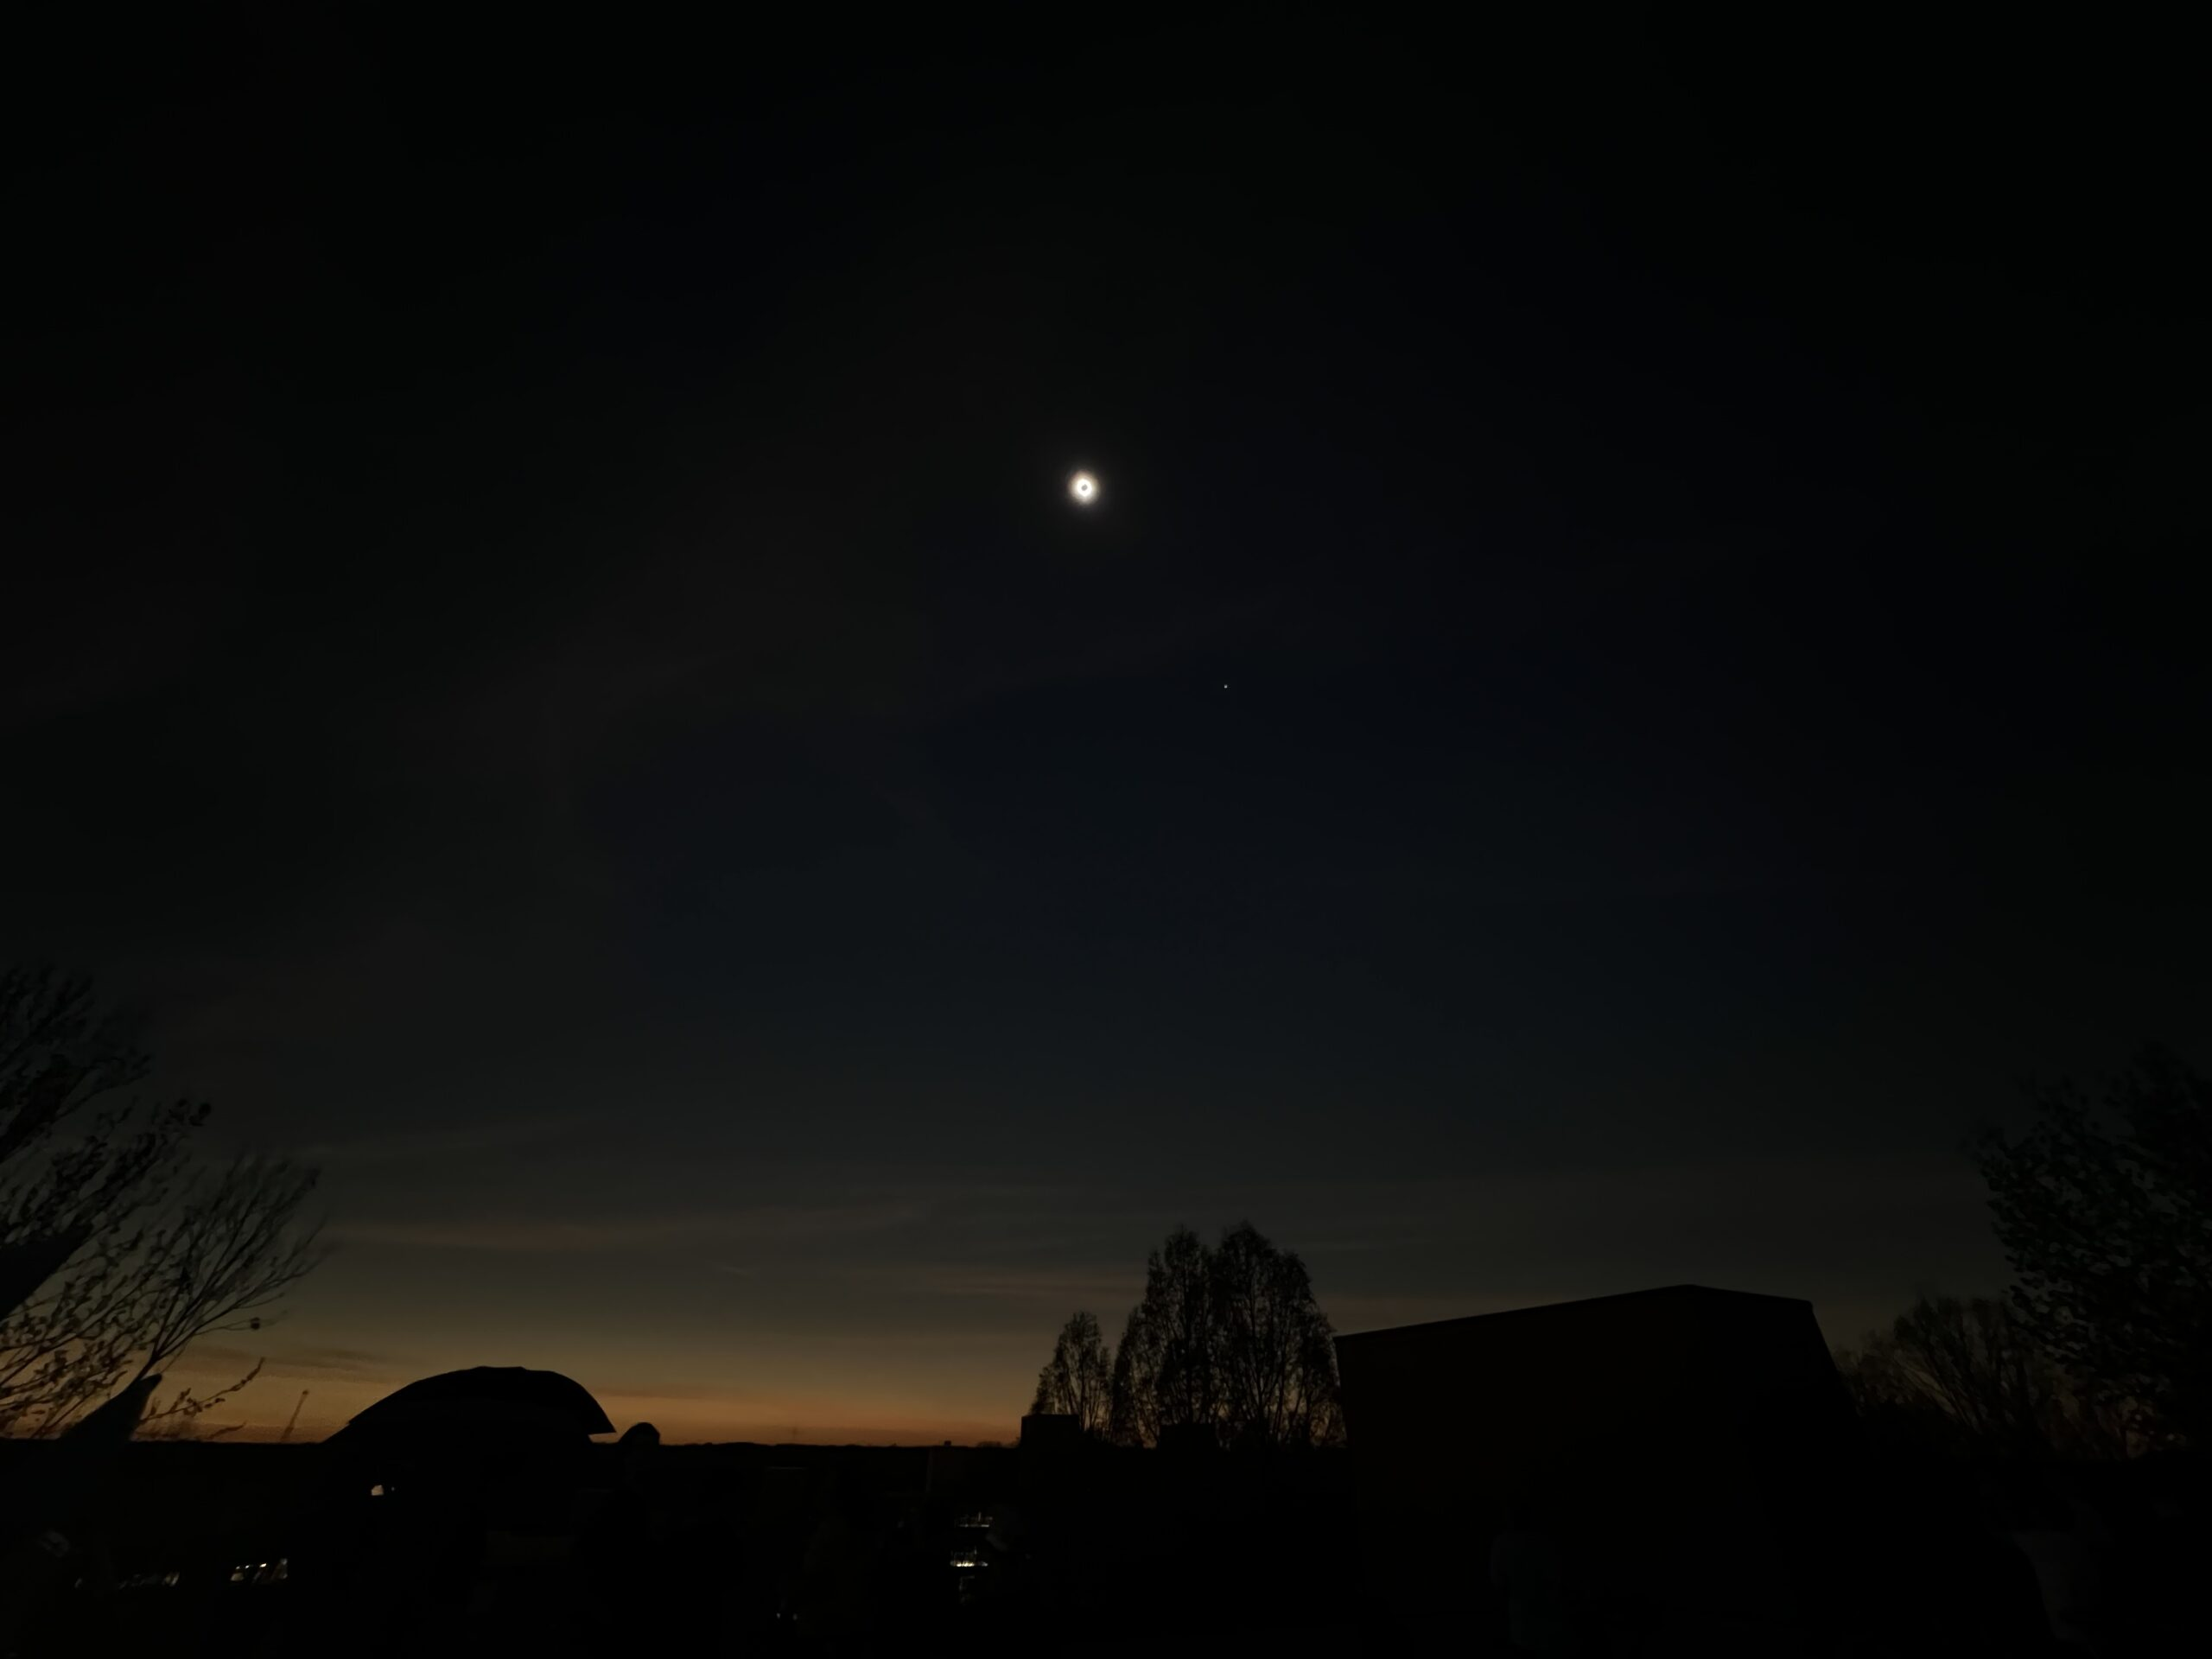
Figure 8

On our team’s livestream of the total eclipse on YouTube, totality occurs at the 1 hour and 10 min. mark. Quotes from the students during totality include: “That’s so cool. It’s getting so dark.”, “That is the coolest thing I’ve ever seen.”, “That is insane!”, “It’s like the most horrifying but the most beautiful thing you’ve ever seen.”

Michael Sibbernsen took images of the eclipse using a Seestar S50 telescope and was able to capture some Baily’s Beads. These features are witnessed the seconds prior to, and after, totality during a solar eclipse. The Sun’s light is broken up into bright beads as the decreasing sliver shines through mountains and valleys along the edge of the Moon’s disk. They are named for Francis Baily, who first explained the effect in 1836. (Fig. 9)
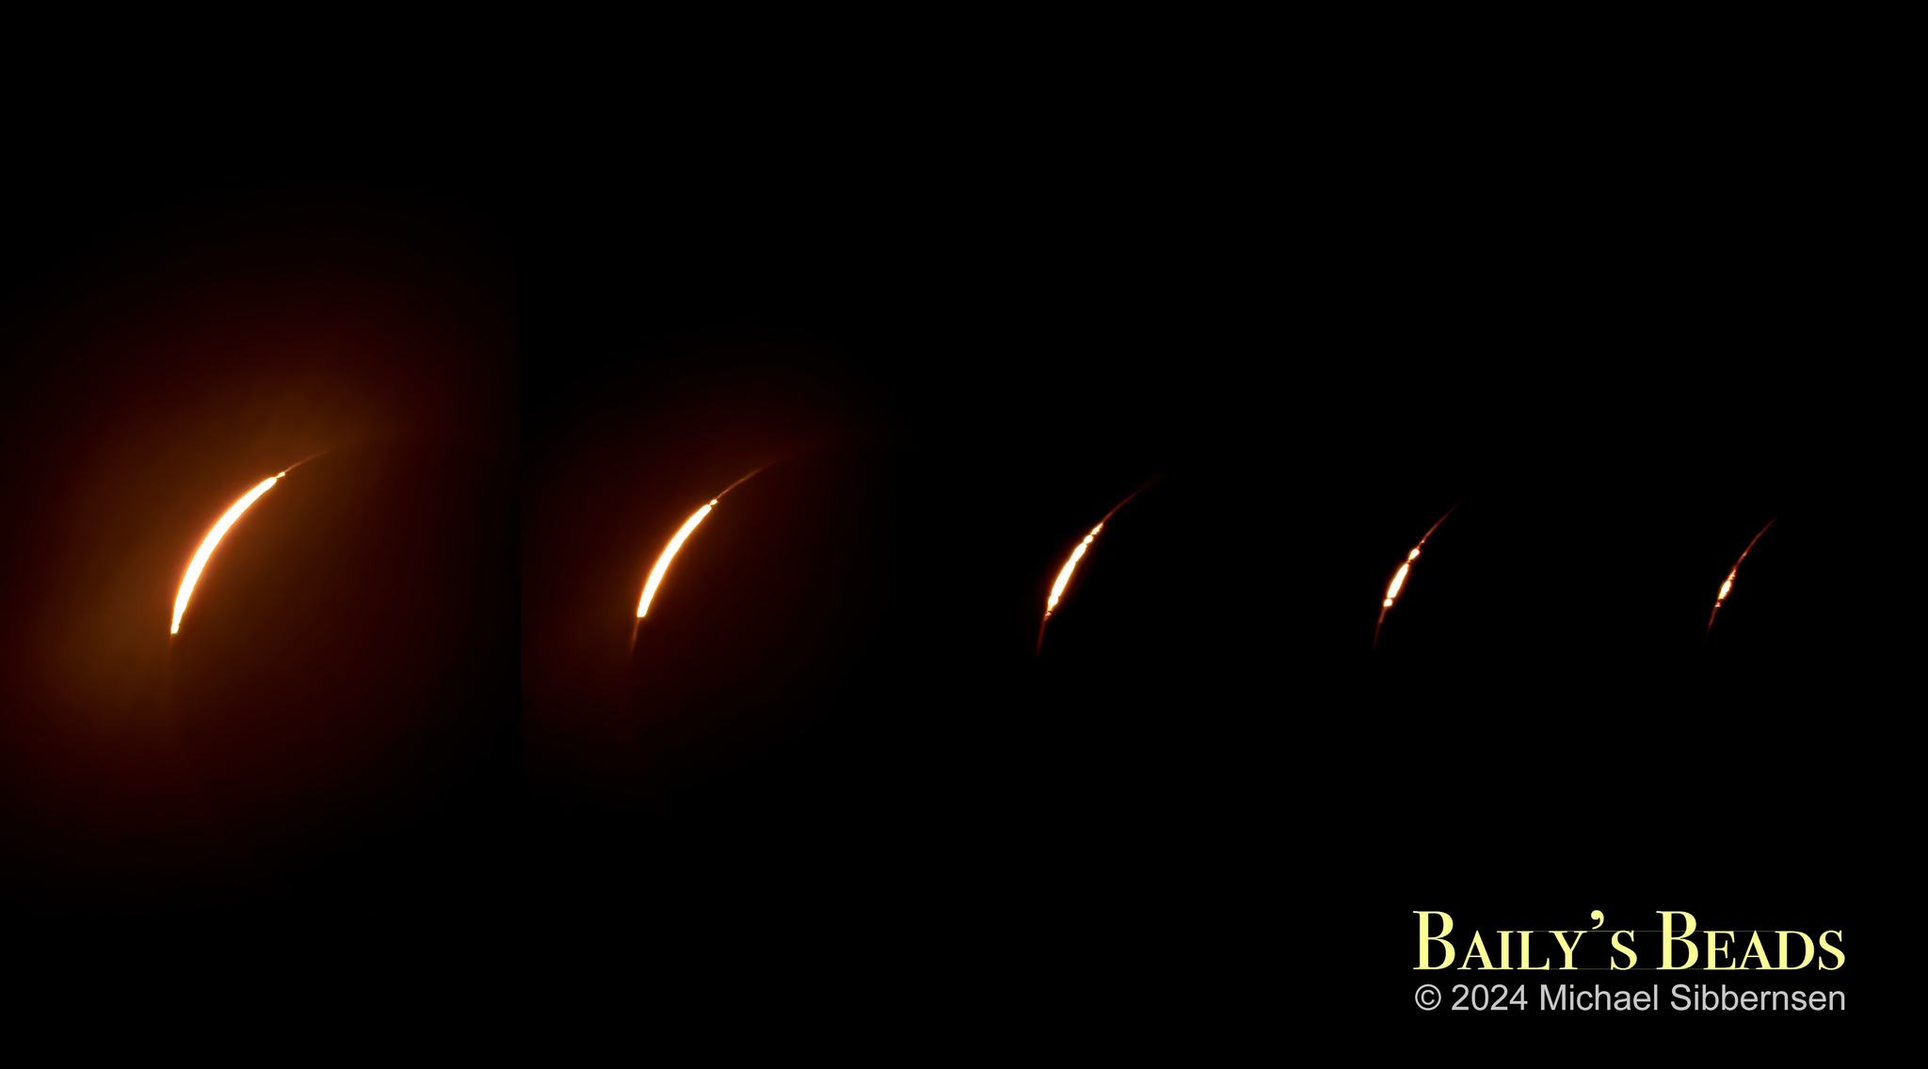
Figure 9

Kendra Sibbernsen was able to capture some elusive shadow bands just moments before totality. The NASA eclipse page says, “Shadow bands are thin wavy lines of alternating light and dark that can be seen moving and undulating in parallel on plain-coloured surfaces immediately before and after a total solar eclipse.” And “In the upper atmosphere there are turbulent cells of air that act like lenses to focus and de-focus the sharp-edged light from the solar surface just before totality.” This video can be seen on her Near Space Science blog at: https://nearspacescience.com/total-solar-eclipse-4-8-24-nebraska-nebp/

Our team was able to recover all three balloons. After totality, the launch team word that our NASA NEBP balloon came down early and was not far away from their location. As we left the launch site, we heard that a homeowner had found our balloon in her yard and we were only 10 minutes away. As with the annular eclipse flight, the balloon was still inflated upon recovery.

The second balloon landed north of Evansville, Indiana. The recovery team discovered it in a tall tree. They tried using our new extendable pole provided by Montana State University to get it down and they were successful.

The third balloon had a very slow ascent and almost made it to Kentucky. It was determined that Michael and Kendra would drive the 6 hours out of our way to get the last balloon the following day while the rest of the team returned home to Nebraska. The last balloon went about 190 miles as the crow flies (254 miles driving distance) from the launch site and landed in Marengo, Indiana. It also landed in a tall tree and required the extendable pole to recover.

4. Conclusions
Overall, the Nebraska team’s participation in the Nationwide Eclipse Ballooning project was a resounding success. We trained mentors and included dozens of Nebraska students in the building of scientific payloads for the engineering track over two years in preparation for the total eclipse. We were able to successfully stream video from our NEBP balloon to our base station for well over an hour during the annular eclipse. We launched three high altitude balloons prior to the total solar eclipse and we recovered all three balloons including all of the tracking equipment and, most importantly, all of the students and mentors who traveled to the total solar eclipse were able to view totality with clear skies.

We had three forms of tracking on each balloon and a flight computer recording information such as position, altitude, temperature, and acceleration. For the first balloon (the NEBP stack), we used the Iridium payload provided for GPS location. We used the RFD 900 system to record data. For the second balloon, we used the StratoStar SatCom system to record data in flight. For the third balloon, we used the PTERODACTYL as the flight computer. For back-up tracking, we used APRS systems and several SPOT trackers.

Unfortunately, we do not have good video footage from altitude for the eclipse. The first balloon (the NEBP streaming video stack) only went up 4500 ft. and was likely on the ground prior to eclipse. The second balloon had a regular GoPro camera on it, but it was pointed down and shut off 10 minutes prior to eclipse. The third balloon had a very slow ascent, went almost 200 miles and had a 360 camera, but that camera was ripped off during the flight.

Because our NEBP balloon only went to about 4500 ft, there was either a leak in the vent or difficulty with the lifting gas or a combination of these factors. We suspect that many of our flight problems were caused by getting a low grade or “balloon grade” helium delivered to us in Carbondale, Illinois. We had trouble getting enough lift with the same number of helium cylinders that we usually use. For example, in Roswell for the annular eclipse, we used 1 ½ cylinders to get enough lift for a 12 pound stack. Our first balloon accidentally released from the vent just moments before launch in Roswell. We had 3 cylinders total and were able to get the back-up balloon attached and filled with the remaining 1 ½ cylinders for a successful flight in New Mexico. In addition, the University of Hartford was set up next to us at Oak Ridge High School in Missouri so our balloons could pass overhead where our base stations were set up in Carbondale, Illinois. Their team had 2 cylinders of helium and completely put both of them in their balloon and still did not have enough lift. They borrowed one of our cylinders to get enough gas so they ended up putting about 2 ¼ cylinders in their balloon to get their 12 pound stack in the air.

As far as our student experiment payloads, many of them had issues with the programming to record the data on-board. Because of the very long flight of our third balloon, an experiment using UV sensors overwrote the data on the SD card and the UV data from the eclipse was lost. This payload was successful at getting data during a practice flight when no eclipse was occurring. These data were “noisy,” but generally showed an increase in all channels as it ascended through the atmosphere. A cosmic ray detector was flown, but also had no data recovered. The Big Red Satellite team, a group of high school and middle school students in collaboration with undergraduates at UNL, put together a solar panel payload with sensors, but this only gathered data through about 20 minutes after launch and then turned off. They are uncertain if it was a battery issue or a temperature issue that caused the shutdown.

The final student payload mixed science and art by putting paint in balloons expecting them to explode as it ascended and splatter on canvases to paint a picture of an eclipse during the eclipse. During a practice flight, they found only two of 16 balloons popped. They re-designed their techniques for filling the paint in the balloons and had most of the 16 balloons explode for the total eclipse. However, because of the long ascent, the paint seemed to freeze and rather than splattering, fell in blobs on the canvases. (Fig. 10)

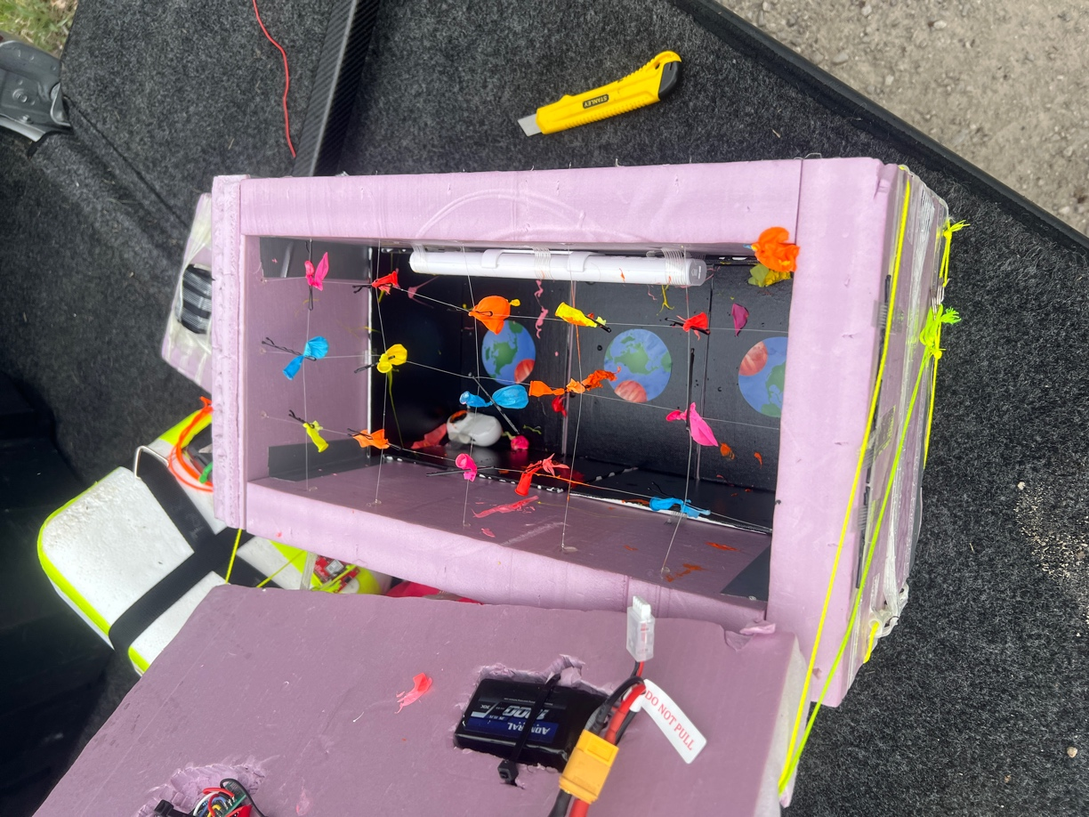
Figure 10

Acknowledgments

Our team would like to thank all of the people and institutions that have supported us throughout this incredible endeavor:
Angela Des Jardins and Randy Larimer and the national NEBP leadership
Michaela Lucas and the entire NASA Nebraska Space Grant staff
Mike Flesch and Tom McDonnell and the grants office staff at Metropolitan Community College
Lance Perez and the administration at the University of Nebraska – Lincoln
Neal Grandgenett and the administration at the University of Nebraska at Omaha
Bob Baer and Steve Gariepy and the staff at Southern Illinois University in Carbondale
Paul Slaford and Enrico Obst and the NEBP team at the University of Hartford
Matthew Nelson and Brody Echer and the NEBP team from Iowa State University
James Flaten as our Pod lead and the NEBP team from the University of Minnesota
The Aerospace eXperimental Payloads (AXP) team, the Big Red Satellite (BRS) Club and all of the friends and family who have supported us over the past two years

References
- https://eclipse.montana.edu
- https://nearspacescience.com/nebp-annular-eclipse-10-14-23/
- https://nearspacescience.com/total-solar-eclipse-4-8-24/

