Gradable Zero Waste: Space Lace Dress

Casey R. Stannard, Louisiana State University

Keywords: Zero Waste, pattern grading, mass market, eveningwear

Zero Waste (ZW) design is “fashion design that wastes no fabric, by integrating pattern cutting into the design process” (Rissanen & McQuillan, 2016, p. 11). For a ZW pattern to fit all available material, it is often necessary to create a garment that is either oversized or has surface “ornamentation” to utilize the extra scraps that appear around a shaped pattern (Rissanen & McQuillan, 2016). However, scholars have found consumers prefer ZW garments to look like traditional patternmaking garments (Michaelson & Chattaraman, 2017). Designing ZW that looks like a traditionally patterned garment creates a special challenge when approaching the apparel category of women’s eveningwear, as it is typically highly fitted to the body, requiring curved seams to follow the feminine form. ZW patternmaking is also challenging as it is nearly impossible to create a size run without sacrificing the aesthetic qualities of the size extremes (smallest and largest sizes). Designer, Carrico (2018, 2020a, 2020b) pioneered a method of grading ZW designs by inserting strips of fabric into strategically placed seams. This grading method allows garments to grow or shrink without disturbing the original ZW pattern/marker. However, this method has not been applied to a complex eveningwear pattern. Thus, the purpose of this design was to create gradable eveningwear using a ZW approach.

To begin, the designer determined where the graded seamlines should be located. The designer utilized a grading approach based on Mullet (2018), where vertical grade distribution lines were placed at the center front, center back, side seams, and over the front and back princess seams. Horizontal grade distribution lines were located under the bust and at the hip. The designer wanted all sizes of the resulting design to have the inserted grading strips so that the effect would be somewhat uniform. Once all the seamlines were determined, the designer figured out the grading system (Mullet, 2018) to be applied for the size run (see Table 1).

Table 1: Grade distributions by size and seam location Next, with the graded seam
Seamline | Size 4 | Size 6 | Size 8 | Size 10 | Size 12
CF/CB | 0.25” | 0.5” | 0.75” | 1” | 1.25”
Side Seams | 0.25” | 0.5” | 0.75” | 1.125” | 1.5”
Princess | 0.25” | 0.25” | 0.25” | 0.3125” | 0.375”
Underbust | 0.25” | 0.375” | 0.5” | 0.625” | 0.75”
Hip | 0.25” | 0.375” | 0.5” | 0.625” | 0.75”
locations in mind, the designer began to think of possible ZW patterns for eveningwear. As shaped patterns would not easily puzzle together, the designer focused on rectangles with darts for fit. The location of the graded seams gave a final corset-like aesthetic that was appropriate for eveningwear. The designer draped a sample on a size 8 dressform and produced a pattern, which was digitized to Adobe Illustrator. Next, the necessary width for each graded strip was subtracted from each pattern seamline. The pattern (which featured a full, self-lining) was puzzled together to create a ZW marker for 58” wide fabric with a long, four-gored skirt. The muslin was sewn and fit on the form. The designer determined the skirt to be unattractive. Thus, a second ZW pattern was developed with a shorter skirt, straps, and bow to accommodate the remaining fabric (see Fig. 2). The new pieces were sewn to the first muslin (to reduce fabric waste) and evaluated.

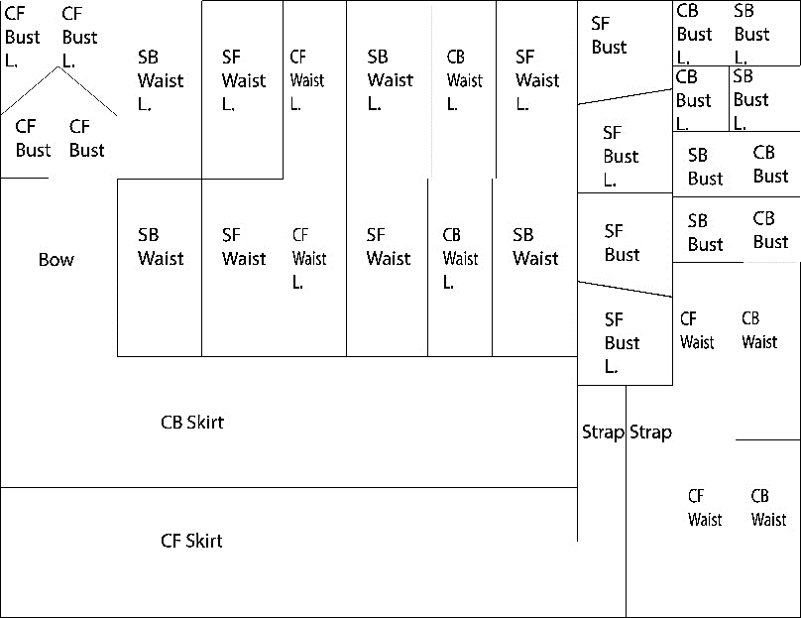
Fig. 2: ZW marker with self-lining
Two additional graded muslins ¬were prepared in the size extremes (4 and 12) to verify the grading (see Fig. 3). The resulting garments fit as anticipated, verifying the method of grading. Upon reflection, the designer determined that the resulting garments were very “cute” and most appropriate for a younger consumer.
The designer began to research trends for tweens and teens, envisioning this design as a good homecoming or party dress. Inspiration was drawn from the zodiac trend of 2021. The designer sought fabric to embody the inspiration and found an embroidered mesh “space lace” to use as an overlay. The lace was marketed as 58” wide but was closer to 50.” This necessitated a ZW marker for the lace. The overlay marker did not need a lining, so two gathered sleeve pieces, a third skirt panel, and a center for the bow were added to utilize the remaining fabric. The lace sleeves added some whimsy to the design and provided more coverage which can be desirable for the target market.

Fig. 3: Size 4,8,12 (Size 8 was a combination of two early ZW patterns)
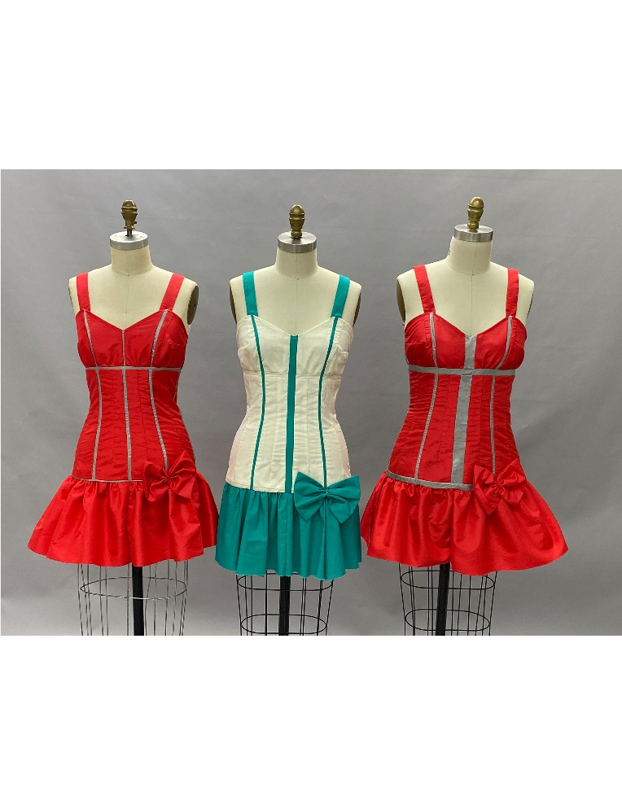
The design was constructed from black 100% polyester satin, which has mass-market appeal and is used for moderately priced eveningwear. Knit fusible interfacing was added to the outer shell pieces for structure. The space lace overlay was flat-lined to the outer shell pieces. The graded strips were the same 100% polyester satin. The strips were not flat-lined to further showcase the interesting, corset-like seaming of the design. The sleeves were sewn with casings and lingerie elastic to allow wearers to comfortably move. The underskirt was hemmed with horsehair braid and boning was sewn to the lining for structure. A center back invisible zipper was used to close the design. Finally, hot-fuse Swarovski crystals were added to the bodice and midriff for sparkle and appeal to the target market.
The present design explored a method of utilizing fabric strips to grade a ZW pattern into multiple sizes (Carrico, 2018, 2020a, 2020b). This design contributes to the knowledge base by demonstrating how to create a fitted, ZW pattern for eveningwear. Future design work should investigate other fitted, ZW patterns and the method of grading using inserted strips of fabric.

Carrico, M. (2020b, November 19-21). Gradable zero waste skirt and blouse [design presentation]. International Textile and Apparel Association National Conference, Virtual. https://doi.org/10.31274/itaa.11790
Carrico, M. (2018, November 5-9). Zero-what? [design presentation]. International Textile and Apparel Association National Conference, Cleveland, OH. https://www.iastatedigitalpress.com/itaa/article/id/1292/
Carrico, M. (2020a, June 30). Grading zero-waste garments [paper presentation]. Sustainability in Fashion Regent’s University London and International Textile and Apparel Association Joint Conference, London, UK. https://doi.org/10.31274/susfashion.11486
Michaelson, D. & Chattaraman, V. (2017, November 14-18) Apparel design for zero waste: Exploring aesthetic preferences and purchase intentions as a function of zero waste design typicality and zero waste concept [oral presentation]. International Textile and Apparel Association National Conference, St. Petersburg, FL. https://lib.dr.iastate.edu/itaa_proceedings/2017/presentations/20
Mullet, K. (2015). Concepts of patterning grading: Techniques for manual and computer grading (3rd ed.). Fairchild Books, Bloomsbury.
Rissanen, T. & McQuillan, H. (2016). Zero waste fashion design. Fairchild Books, Bloomsbury.

