Unraveling Consumer Motivation to Shop Local: Clothing vs. Grocery stores
Hyunjoo Im & Garim Lee, University of Minnesota
Introduction The COVID-19 pandemic affected small local businesses greatly as consumers shopped online mostly. However, a recent survey showed consumers overwhelmingly support local businesses and plan to do so in the future (Mint, 2021). Still, previous research on local retailing is mostly limited to food/grocery shopping (Hashem et al., 2017; Memery et al., 2015) and academic research to understand consumer motivation to support local clothing stores is rare. Thus, the current study aims to investigate motivations for consumer’s willingness to shop at local retailers over national chains in two store categories, grocery and clothing stores. Drawn from the local identity and local consumption literature, this study tested the interactive effects of the localness of the store, consumer local identity, and product category on consumer willingness to shop.
Literature Review According to VBN theory, values, beliefs, and norms together motivate consumers to behave in a consistent way (Stern, 2000). VBN theory has been widely used to explain value-driven behaviors such as supporting social movements or green behaviors. Consistent with the theory, research showed that consumers support local businesses for several benefits including ethical values (i.e., to help their local community) (Miller & Kean, 1997) and beliefs about product quality (Grebitus et al., 2013). Previous research consistently reported these two benefits as local support motives, and researchers concluded that self-interest (i.e., purchasing due to intrinsic product quality) and altruism (i.e., local support) are the only significant predictors of local food purchase behaviors (Megicks et al., 2012; Memery et al., 2015). Thus, consumers will be more willing to shop at a local store than a national chain store (H1), and that the positive local store effect will be explained by (a) altruistic motivation (i.e., ethical value) and (b) self-interest motivation (i.e., quality perception of a store) (H2).
We expect the main effect of local stores to be qualified by two factors: product category and consumer local identity. For grocery stores, consumers often believe that locally owned grocery stores carry fresher and higher quality produce because of the proximity to the local farmers. However, clothing stores will not have such a benefit due to the complex supply chain and manufacturing process. Thus, the positive local store effect is likely to be diminished for clothing stores (H3). A local identity, the degree a consumer identifies with the local community (Zhang & Khare, 2009), is another important factor to form consumer preference for local businesses. In a study of consumer motivation for purchasing locally produced food, Memery et al. (2015) found that local support was amplified when one’s local identity is stronger whereas intrinsic quality perception did not differ among individuals. This implies that strong local identity is likely to strongly promote altruistic motivation, overruling the self-interest motivation. Therefore, it is anticipated that the positive local store effect will be observed for both product categories for high local identity consumers. In contrast, for low local identity consumers, the local store effect will be diminished for clothing stores (H4).
Methods Hypotheses were tested through a 2 (store: local vs. national) × 2 (product: clothing vs. grocery) × 2 (local identity: low vs. high) between-subjects online experiment (n=189, Amazon Mturk, Age: M=39.28, SD=11.96; Female: 46.0%). The participants were randomly assigned to one of the 8 experimental conditions, read a hypothetical shopping scenario varying the store and product type, and completed the questionnaire. The participants’ local identity was measured and a median split was used to create local identity conditions. The scales measuring local identity, quality, ethical value, and willingness to shop were adapted from the past literature.
Results Manipulation of the local (vs. national) store was successful (M_{local}=1.62 vs. M_{national}=3.19, t=-8.37, p<.001). Consistent with H1, the participants were more willing to shop at the local store than the national chain store (M_{local}=4.35 vs. M_{national}=4.17; F(1, 181)=3.83, p=.05, partial η²=.02). PROCESS macro (Hayes, 2018) was used to test if ethical value and perceived quality were significant mediators. The effect of store type on the participants’ willingness to shop was mediated by ethical value (indirect effect=-.17, 95% CI[-.28, -.05]) and perceived quality (indirect effect=-.09, 95% CI[-.18, -.03]), supporting H2.
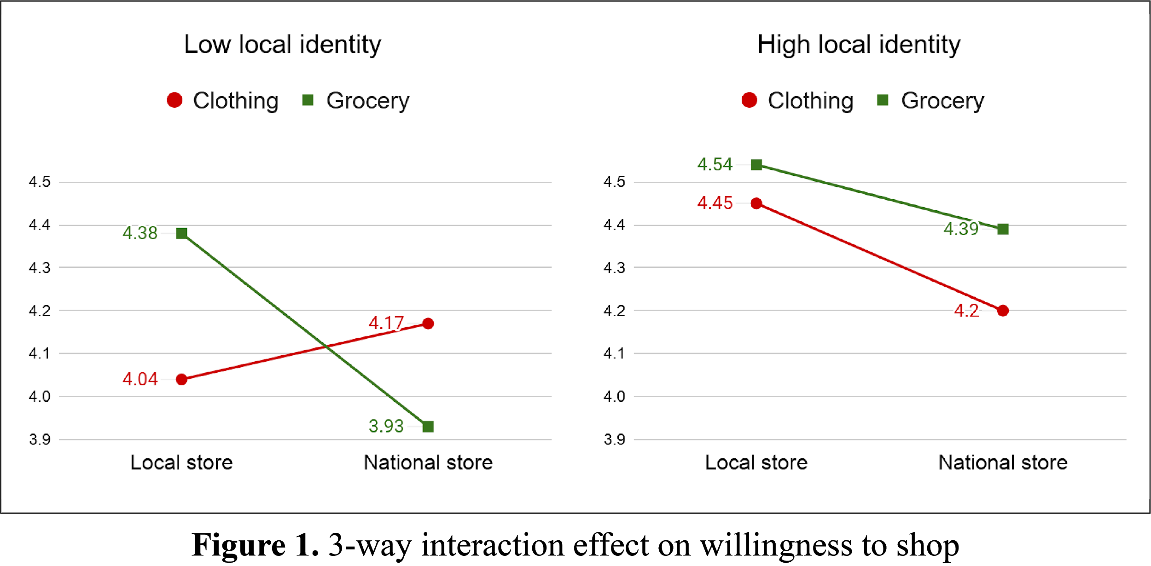
Consistent with H3, product type moderated the indirect effect of the store type on willingness to shop through perceived quality (moderated mediation index=-.14, 95% CI[-.31, -.01]). The result showed that willingness to shop is predicted by perceived quality not for clothing (effect=-.02, 95% CI[-.11, .07]) but for grocery (effect=-.16, 95% CI[-.30, -.06]). Lastly, the 3-way interaction between store type, product type, and local identity was marginally significant (F=3.55, p=.061, η²=.02, see Figure 1). The conditional moderated mediation analysis revealed that the product type moderated the indirect effect of the store type on willingness to shop for low local identity participants (index=-.17, 95% CI[-.39, -.01]) but not for high local identity participants (index=-.10, 95% CI[-.25, .00]). The high local identity participants were more inclined to shop at the local stores regardless of the product type (i.e., grocery and clothing). In contrast, the low local identity participants were more willing to shop at a local store than a national chain store only in the grocery store condition. For clothing stores, the low local identity participants were more willing to shop at the national than local store. Thus, H4 was supported.
Discussion & Implications Our results confirmed that consumers are generally willing to shop at local stores over national chains for both altruistic and self-interest motivations. Perceived quality of products explained the local store preference effect only for grocery stores. This may be because local grocery items (i.e., produce) are generally considered superior due to the assumed short time between harvest and actual consumption, while this is not the case for clothing items. The perception of local produce is likely transferred to store perception. Importantly, the local appeal was limited to grocery stores for consumers with low local identity whereas consumers with high local identity showed local preference for both products. This finding implies that small business owners cannot expect all consumers to respond positively to ‘buy local’ messages. As the local identity could be temporarily enhanced, clothing retailers may develop a strategy to build their local connection more strongly and make consumer local identity salient. A future study to test the strategies will be beneficial.

References
Grebitus, C., Lusk, J. L., & Nayga, R. M. (2013). Effect of distance of transportation on willingness to pay for food. Ecological Economics, 88, 67-75.
Hashem, S., Migliore, G., Schfani, G., Schimmenti, E., & Padel, S. (2017). Motives for buying local, organic food through English box schemes. British Food Journal, 120(7), 1600-1614.
Hayes, A. F. (2018). Introduction to mediation, moderation, and conditional process analysis: A regression-based approach. Guilford publications.
Megicks, P. M., Memery, J., & Angell, R. J. (2012). Understanding local food shopping: Unpacking the ethical dimension. Journal of Marketing Management. 28(3-4), 264-289.
Memery, J., Angell, R., Megicks, P., & Lindgreen, A. (2015). Unpicking motives to purchase locally-produced food: analysis of direct and moderation effects. European Journal of Marketing, 49(7/8), 1207-1233.
Miller, N. J., & Kean, R. C. (1997). Reciprocal exchange in rural communities: Consumers’ inducements to inshop. Psychology & Marketing, 14(7), 637-661.
Mint. (2021). Buying local statistics for 2021: Survey finds 70% of Americans shop small. Retrieved from https://mint.intuit.com/blog/money-etiquette/buying-local-statistics-survey/.
Stern, P. C. (2000). Toward a coherent theory of environmentally significant behavior. Journal of Social Issues, 56, 407-424.
Zhang, Y., & Khare, A. (2009). The impact of accessible identities on evaluation of global versus local products. Journal of Consumer Research, 36(3), 524-537.

