From Crown to Couture
Juliann Yusko and Armine Ghalachyan (mentor)
Department of Apparel, Merchandising, Design and Textiles
Washington State University
Keywords: Sustainability, upcycling, zero waste, textile waste, textile packaging, overpackaging
Design concept and purpose: This design is a wearable, royalty inspired symbol of the waste that is produced in our society, especially waste due to overpackaging and luxury packaging. Crown Royal, a Canadian Whisky, was created in 1939 for King George VI’s visit to Canada. Everything about it, from the taste to the bottle design to the bag it came in was designed to be fit for royalty (Crown Royal, 2022). The royal purple bag with gold stitching has become an iconic part of their branding and continues to be used as part of the packaging of a bottle of Crown Royal over eighty years later. This branding is designed show the luxury of the product inside.
While textile and other miscellaneous packaging in most recent estimates only accounted for an estimated .4% of all container and packaging waste, none of it went to recycling or composting, and only 20.6% of the miscellaneous packaging waste was combusted with energy recovery. The remaining miscellaneous packaging waste, including textile packaging, was landfilled (United States Environmental Protection Agency, 2022). The overall concept of this design was to create a luxurious, royal gown and accessories by upcycling the textile bags, while also having as little leftover waste as possible and preventing waste from entering the landfill. Any additional materials used, such as elastics, grommets, and aglets were also reclaimed left-over production materials. The design was created to encourage awareness of consumption and consumer waste, especially as it comes to overpackaging and luxury packaging, as well as to illustrate a method for creating a high-quality garment using textile waste, including pieces that utilize leftover scraps, threads, trims, and fasteners.
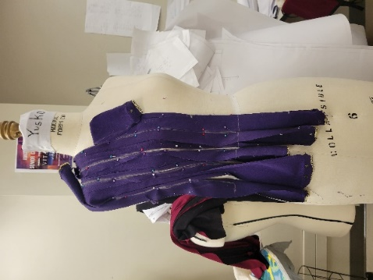
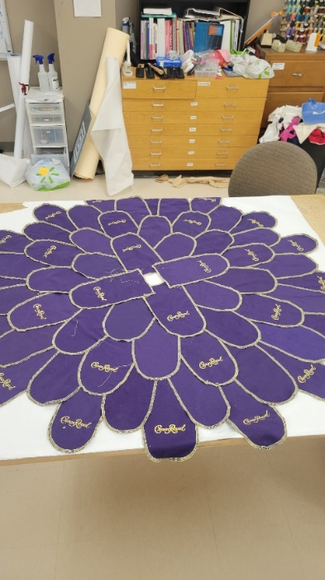
Design, process, and techniques: This design consists of four components: a gown, a collar, a headpiece, and a pair of cuffs. The first stage of the design process was disassembling over sixty Crown Royal bags, which was done by undoing all the seams and saving all pieces of the bag, including the drawstrings and thread. The gown has a corset style bodice and a petaled full circle skirt. The bodice was created by draping half of the bodice with the long side panels of the bags (Figure 1). A pattern was then created from these draped pieces to create the other half of the bodice as well as the lining of the bodice. After all panels of the exterior were sewn together, the drawstrings of the bags were sewn to each seam as a decorative detail to emulate piping. All scraps from the bodice were saved to be used later. The edges of the front and back bag panels were re-serged to prevent fraying, then an adhesive spray was used to connect the pieces together so they could be permanently sewn to create the full circle skirt (Figure 2). After attaching the bodice to the skirt and hand sewing the lining closed, two bag side strips were used to trim the raw edges of the center back seam. This also provided extra strength for the addition of grommets, which were also leftover production materials from prior projects. Drawstrings from two bags were used as corset lacing, with aglets, other left-over production materials, being used to protect the ends.
Figure 1. Draped bodice
Figure 2. Petaled circle skirt arrangement
The collar was created with a single bag side panel and used left-over cord elastic to shirr it and create gathers. Bag drawstrings were knotted together using two macramé knots, the lark’s head knot and square knots. The initial and final knots were also melted together to add additional stability. The macramé piece of the collar was hand sewn to the shirred piece, and an additional piece of drawstring was used as a lacing closure at the back neck.
The headpiece was created by quartering a bag side panel, and after finishing the edges, gathering one side, and rolling it to create a rose. These roses were alternated with the plastic Crown bottle caps and glued onto an old, gold-painted headband to create a “crown of crowns.”
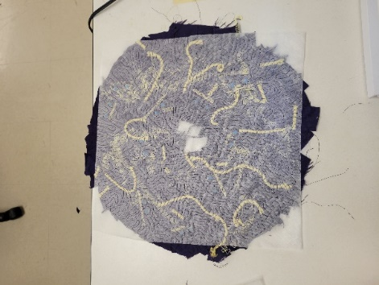
The final pieces of the design, the cuffs, were created by using the scraps of fabric that had previously been saved from all other parts of the design to create an upcycled piece of fabric. The main bag scraps were first laid out on a piece of wash away stabilizer, and scraps of drawstring as well as strands of the thread that was initially removed when disassembling the bags were used to bring in the golden color as decorative accents. Another piece of stabilizer was placed on top to sandwich the scraps, and the entire piece was free form machine embroidered (Figure 3). After the stabilizer was washed away, more scraps were stitched on to the back side to cover thin spots. Two bag side panels were sewn together to create a loop, and one edge was gathered then sewn to the inner edge of each cuff to create a frill. An additional bag side panel was used to create a casing for re-used elastic on each cuff.
Figure 3. Cuff design process
Innovation and significance: This upcycled design uses varying techniques in an effort to maximize the use of materials and leave zero waste, while still creating pieces that speak to the royal history of the product used to create them. Upcycling used textiles can often results in considerable amount of leftover textile waste as it is difficult to effectively utilize the entire product. The dress also serves as a communication medium to encourage the viewer to think about their own consumption and the waste associated with products they purchase. The design also raises awareness of the tremendous amount of waste generated as a result of branding and overpackaging.
References
Crown Royal. (2022). Our history. https://www.crownroyal.com/story/our-history/
United States Environmental Protection Agency. (2022). Containers and Packaging: Product-Specific Data. https://www.epa.gov/facts-and-figures-about-materials-waste-and-recycling/containers-and-packaging-product-specific

