Developing and validating scales to assess fashion organizations’ change-related effort toward the circular economy
Chung-Wha (Chloe) Ki, Hong Kong Polytechnic University, Hong Kong SAR
Sze Man Chong, Hong Kong Polytechnic University, Hong Kong SAR
Ashley Chenn, Hong Kong Polytechnic University, Hong Kong SAR
Baolu Wang, Beijing Institute of Fashion Technology, Mainland China
Jung Ha-Brookshire, University of Missouri, USA
Keywords: Circular Fashion; Circular Economy; Change-Related Effort; Scale Development

Phenomenon, problem, and purpose statements: In the prevailing linear economic (LE) model, fashion organizations (including textile and apparel [T&A] organizations) have contributed substantially to environmental damage (McDonough & Braungart, 2002). This detrimental environmental damage has prompted calls to transition from the LE’s “take-make-waste” business model to a more sustainable, circular economic (CE) model that emphasizes “reuse and regeneration” (Legl, 2022). Among those calling for a shift to the CE are Chinese policymakers. As China’s fashion industry is the world’s largest producer and exporter of T&A (United Nations Comtrade, 2022; WTO, 2022), it contributes significantly to the nation’s air and water pollution. To address this issue, the Chinese government has made increasing “change-related efforts” toward the CE, including its stated goal to recycle 25% of all textile waste and produce 2.2 million tons of recycled fiber within the next two years (Choi, 2022) in order to combat the 26 million tons of used clothing being discarded every year (To & Kan, 2020). Due to this external pressure and government regulations, some fashion organizations have begun to adopt CE business models that consider clothing as a service rather than a product (e.g., rental clothing models), while others have begun to engage their customers in CE practices through take-back offers (e.g., a fashion organization takes or buys back its own garments; Ki et al., 2020). Despite these efforts, it still remains unclear whether Chinese fashion organizations have the intrinsic motivation to champion efforts to change toward the CE, which can translate into positive economic, environmental, and social outcomes. This led us to develop an important research question: “Are Chinese fashion organizations making tangible efforts to change toward the CE at their own will?” To answer this question, we drew on the theory of organizational readiness for change (ORC; Weiner, 2009) and the methodological framework of item response theory (IRT; Revicki et al., 2014) to develop and validate a context-specific scale that measures change-related effort toward the CE, tailored to Chinese fashion organizations given their key position in the fashion value chain.
Theoretical framework: ORC is based on the premise that organizations encounter unexpected, yet critical and continuous change and therefore proposes that readily embracing and adapting to change (e.g., a change to the CE) at their own accord is critical for their business success (Weiner, 2009). This internally-driven motivation to adapt/change fosters a higher level of change commitment, change efficacy, change-related effort, and implementation effectiveness (Weiner, 2009). Change commitment (i.e., the intrinsic motivation to enact change) and change efficacy (i.e., the capability to respond to change) comprise the construct of change readiness, which is defined as how prepared an organization is to execute change (Holt & Vardaman, 2013). Change readiness results in change-related effort, which Weiner (2009) defines as the collaborative and championing behaviors that an organization exhibits toward a specific change. This in turn affects implementation effectiveness (i.e., the consistency and quality of change-related outcomes). While a scale measuring fashion organizations’ change readiness is introduced and developed (Ki et al., 2022), the current literature still lacks a valid and reliable scale to measure fashion organizations’ change-related effort toward the CE. Change-related effort is an important construct to assess because of the convoluted and complex nature of the fashion value chain, which covers a range of functions from design to sourcing to waste management.
Method and results: While ORC theory offers a useful framework to understand the major constructs to assess organizational change, it does not explain the specific dimensions necessary to measure and assess the change-related effort of a Chinese fashion organization. To fill this gap, we first conducted a systematic literature review to determine the dimensions of change-related effort specific to Chinese fashion organizations. From this review, we found six dimensions associated with change-related effort, including eco-design, green sourcing, cleaner production, innovative business models, waste management, and customer engagement. Then, guided by IRT, a paradigm for investigating the relationship between an individual’s response to an item and an individual’s level of the latent trait (Wang et al., 2022), we applied a mixed-methods approach across three phases of study (see Figure 1). First, we generated pool of initial items (n=267) for each dimension based on the systematic literature review and purified the initial items through binning (i.e., grouping) and winnowing (i.e., reducing). After binning and winnowing, 26 items remained. Second, we further refined items based on focus group sessions (n=9) and cognitive interviews (n=10) with Chinese fashion firm managers, which led to 25 expert-validated items. Third, we quantitatively validated the items using an online survey (n=500) via wenjuan.com and conducted reliability, construct validity, and test-fairness assessments on each item. As depicted in Table 1, the results of the study ultimately yielded seven valid scale items of change-related effort.
Implications: Our change-related effort scale allows researchers, leaders of fashion organizations, and policymakers to measure the change-related efforts of Chinese fashion organizations, contributing to both theory and practice in several key aspects. First, our scale represents one of the first studies to measure change-related effort toward the CE using Chinese fashion organizations as the primary sample, providing a reliable and valid measurement tool. Second, this scale provides a current, context-specific measurement tool. As more fashion organizations shift toward the CE, this enables researchers to measure the key constructs relevant to shifting fashion organizations toward the CE, thus maintaining pace with the rapid advancements taking place in the fashion industry. Third, practitioners can use our scale to measure their organization’s level of change-related effort and identify areas for improvement. This in turn allows the fashion organization to tailor where it focuses less or more effort and accomplish an effective shift toward the CE.

Figure 1.
Summary of the item development process
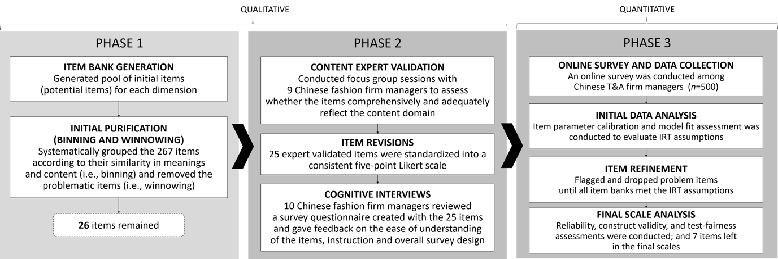

Table 1.
Item parameter estimates and item fit statistics for the final change-related effort scale (n=7)
Dimension | Item | a | S_X² | df | p | M₂ | α
Eco-design | The firm strives to implement the CE by designing products and/or services for low waste. | .99 | 17.52 | 15 | .29 | M₂(5)  = 4.61  RMSEA₂  = .06  SRMR  = .03  CFI  = .98  TLI  = .99 | .82
 | The firm strives to implement the CE by designing products and/or services for longevity. | 1.00 | 22.95 | 15 | .09
Green sourcing | The firm strives to implement the CE by mentoring suppliers to improve their CE performance. | .79 | 21.29 | 15 | .13
Cleaner production | The firm strives to implement the CE by replacing materials used in the production processes with less toxic, renewable, recyclable, and biodegradable materials. | .88 | 9.24 | 15 | .87
Innovative business models | The firm strives to implement the CE by adopting and/or providing new business models. | 1.13 | 27.09 | 17 | .06
Waste management | The firm strives to implement the CE by providing activities/programs for extending the lifespan of materials. | .83 | 15.88 | 15 | .39
Customer engagement | The firm strives to implement the CE by educating customers about how to take care of the products in order to extend product life or reduce waste. | 1.02 | 18.27 | 15 | .25
Note: Only the English version is provided due to page limitation
References
Choi, M. (2022). China’s climate goals: Beijing aims to recycle 25 per cent of all textile waste, increase recycled fibre output by 2025. South China Morning Post. https://www.scmp.com/business/china-business/article/3174015/chinas-climate-goals-beijing-aims-recycle-25-cent-all
Holt, D. T., & Vardaman, J. M. (2013). Toward a comprehensive understanding of readiness for change: The case for an expanded conceptualization. Journal of Change Management, 13(1), 9-18. https://doi.org/10.1080/14697017.2013.768426
Ki, C.-W. C., Wang, B., Chong, S. M., & Ha-Brookshire, J. E. (2022). Is the Fashion Industry Ready for a Change Toward a Circular Economy (FashionReady4CE)? Development of IRT-Based FashionReady4CE Scales. International Textile and Apparel Association Annual Conference Proceedings.
Ki, C. W., Chong, S. M., & Ha‐Brookshire, J. E. (2020). How fashion can achieve sustainable development through a circular economy and stakeholder engagement: A systematic literature review. Corporate Social Responsibility and Environmental Management, 27(6), 2401-2424.
Legl, C. (2022, 2022, June 29). Why The Circular Economy Is The Perfect Fit For The Fashion Industry. Forbes. https://www.forbes.com/sites/sap/2022/06/29/why-the-circular-economy-is-the-perfect-fit-for-the-fashion-industry/
McDonough, W., & Braungart, M. (2002). Cradle to Cradle: Remaking the Way We Make Things. North Point Press.
Revicki, D. A., Chen, W.-H., & Tucker, C. (2014). Developing item banks for patient-reported health outcomes. In S. P. Reise & D. A. Revicki (Eds.), Handbook of Item Response Theory Modeling: Applications to Typical Performance Assessment (pp. 352-381). Routledge.
To, E., & Kan, K. (2020). China’s Next Problem Is Recycling 26 Million Tons of Discarded Clothes. Bloomberg. https://www.bloomberg.com/news/features/2020-10-18/china-s-big-fashion-problem-is-recycling-26-million-tons-of-used-clothes
United Nations Comtrade. (2022). Leading importing countries of textile apparel goods worldwide in 2021 (in million U.S. dollars). In Statista.
Wang, B., Ha-Brookshire, J. E., & Bonifay, W. (2022). Measuring perceived benefits and costs of new technology adoption in the Chinese textile and apparel industry. Clothing and Textiles Research Journal, 40(3), 187-202. https://doi.org/10.1177/0887302X20969889
Weiner, B. J. (2009). A theory of organizational readiness for change. Implementation Science, 4(1), 1-9, Article 67. https://doi.org/10.1186/1748-5908-4-67
WTO. (2022). Top textile exporting countries worldwide 2021 (in billion U.S. dollars). In Statista.

