How humanized virtual influencers engage users: A comparative case study of three virtual influencers

Terry Haekyung Kim & Hyunjoo Im, University of Minnesota, USA
Naan Ju, Dong-A University, South Korea

Keywords: Virtual influencer, anthropomorphism, engagement, trans-parasocial relation framework

Introduction Virtual influencers (VIs) are computer-generated influencers that can behave and appear like humans (da Silva Oliveira & Chimenti, 2021). Humanized virtual influencers (HVIs) are hyper-realistic human-like VIs that create content, interact with followers, and collaborate with brands in advertisements. HVIs are gaining popularity in marketing due to their novelty, availability, and flexibility (Sands et al., 2022). However, not all HVIs are thriving, with 57% losing their followers in 2022 (Baklanov, 2022). Therefore, this study aims to discover the factors contributing to users’ engagement with HVIs (i.e., likes and comments) by investigating popular social media posts and how HVIs present themselves to their audience.

Literature review Anthropomorphism refers to the tendency to attribute human-like characteristics, intentions, and behavior to nonhuman objects (Aggarwal & McGill, 2007). The literature explains that the perceived similarity between humans and the human-like characteristics of nonhuman objects (i.e., anthropomorphism) increases the accessibility of human schema, leading to the application of social expectations in interactions with nonhuman entities (Epley et al., 2007). Humanized virtual influencers (HVIs) present their personas and storylines on social media, leading to more direct user interactions (Arsenyan & Mirowska, 2021). Consequently, HVIs will likely engage consumers through their human-like representations and interactions in social media posts much like real-human influencers.
According to the trans-parasocial relation framework (Lou, 2022), social media influencers build bi-directional, co-creating relations with followers, which distinguishes influencer marketing from traditional mass-media marketing. Because social media forms a reciprocal community, users are positively biased and exhibit trusting behaviors even when the influencers openly engage in marketing activities (e.g., sponsored product advertisement) (Lou, 2022). In this bi-directional and reciprocal context, user engagement such as liking and commenting become a critical metric for social media influencers’ success (Coelho et al., 2016). While both liking and commenting are common measures of engagement, commenting is the higher level of engagement than liking, as it requires more effort and allows users to directly engage with a content creator (Cho et al., 2014). Social media influencers’ posts such as contents and the way they are written (e.g., communication style, content topic, entertainment value) can increase user engagement (Lim & Rasul, 2022). Similarly, the HVI’s activities (i.e., content) will also likely influence the level of user engagement. Therefore, the current study will identify success factors by analyzing successful HVIs’ posts. Specifically, the research questions are: RQ1) Are certain types of HVIs’ activities associated with higher user engagement? RQ2) What are characteristics of HVIs’ posts with high engagement (i.e., likes, comments)?

Methods We used a case study approach to integrate diverse sources of evidence to build a deep within-case understanding of each HVI (Creswell, 2014; Stake, 2008). A comparative case approach is particularly appropriate for this study because the commonalities and/or differences across HVIs can be captured, given the diversity of HVIs. To select the successful HVIs for the case study, 3 researchers listed a total of 196 VIs with complete profiles (e.g., the year of first appearance, country of origin, the number of postings and followers; as of June 2022) and coded the degree of human-like appearance. Among 196, 106 were identified as humanized virtual influencers (HVI). We then selected three HVIs based on the number of followers, the number of posts, and the country of origin: Lil Miquela (@lilmiquela, 2.9M followers), Imma (@imma.gram, 406K followers), and Rozy (@rozy.gram, 149K followers). We collected the three HVIs' Instagram posts, including timestamps, number of likes, number of comments, post content, and comments using Python. This generated 1,178,622 comments and 2,216 posts. Then, newspaper and magazine articles on the selected HVIs were collected. The collected social media posts, comments, and articles were comprehensively analyzed.

Results To answer RQ1, we analyzed the trend of the number of comments for each HVI over time and noted significant fluctuations in the volume of Instagram comments (Fig. 1). Then, HVI activities were identified from the news articles and assessed the level of correspondence with the peaks in the engagement graph. The findings suggest the posts showing three kinds of activities are associated with increased engagement. 1) brand collaborations: Rozy’s appearance in TV ads, Imma’s appearance in an IKEA store, and Miquela’s collaboration with fashion brands increased comments. 2) the HVIs’ appearance in real-life events and interaction with real persons: Rozy’s photoshoots with human celebrities, Miquela kissing Bella Hadid in Calvin Klein’s ad, Imma’s participation in exhibition and the 2020 Paralympics ceremony increased engagement. 3) the HVIs’ personal, emotional, and controversial posts: Miquela’s revelation about her robot identity and her breakup with her human boyfriend resulted in a surge in comments.
Next, an analysis of the characteristics of the post was performed to answer RQ2. The top 5 posts with the most comments and 5 most liked posts for each HVI were analyzed. The results revealed that most liked posts have high informational value. They typically share new information about the HVI (e.g., Miquela’s posts announcing the release of her new song, Imma’s sharing of her new advertisement video and TikTok account, and Rozy’s announcement of her first TV advertisement and photo shoots with celebrities). In contrast, posts with the highest number of comments shared the HVIs’ intimate, personal, and emotional experiences (e.g., Miquela’s posts about discovering her robot identity and her emotional journey to face her confusion, Imma’s participation in TikTok challenges, and Rozy’s birthday celebration).

Fig 1. Comment trend and activities of HVIs
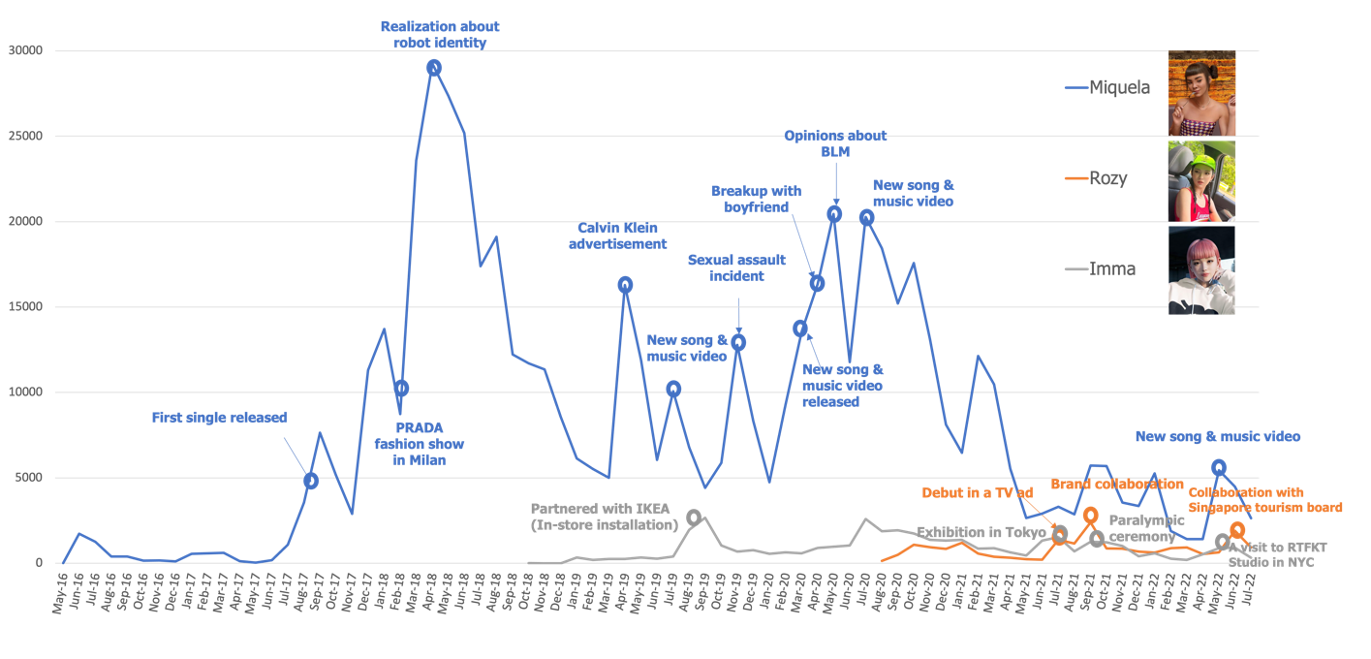

Discussions & Conclusion Our results suggest that consumers indeed anthropomorphize HVIs and engage with them as if they are human influencers. The audience demonstrated a deeper engagement with HVIs when they saw personal and relatable stories, which indicates acceptance of HVIs as humanlike influencers. Our results also support the trans-parasocial relation framework (Lou, 2022) in that the brand-sponsored posts were well-accepted and liked. In terms of practical implications, brands should consider HVIs as collaboration partners and generate events or images that integrate the virtual humans with their stores or other brand ambassadors. Furthermore, it is advisable that HVIs go beyond sharing factual information and create emotional connections with users through convincing and personal stories to promote a deeper level of engagement.

References
Aggarwal, P., & McGill, A. L. (2007). Is that car smiling at me? Schema congruity as a basis for evaluating anthropomorphized products. Journal of Consumer Research, 34(4), 468-479.
Arsenyan, J., & Mirowska, A. (2021). Almost human? A comparative case study on the social media presence of virtual influencers. International Journal of Human-Computer Studies, 155, 102694.
Baklanov, N. (2022, December 21). The top virtual instagram influencers in 2022. HypeAuditor. https://hypeauditor.com/blog/the-top-virtual-instagram-influencers-in-2022/#57--of-virtual-influencers--accounts-are-losing-followers
Cho, M., Schweickart, T., & Haase, A. (2014). Public engagement with nonprofit organizations on Facebook. Public Relations Review, 40(3), 565-567.
Coelho, R. L. F., de Oliveira, D. S., & de Almeida, M. I. S. (2016). Does social media matter for post typology? Impact of post content on Facebook and Instagram metrics. Online Information Review, 40(4), 458-471.
Creswell, J. W. (2014). Research design: Qualitative, quantitative and mixed methods approaches (4th ed.). Thousand Oaks, CA: Sage.
da Silva Oliveira, A. B., & Chimenti, P. (2021). "Humanized Robots": A Proposition of Categories to Understand Virtual Influencers. Australasian Journal of Information Systems, 25, 1-27.
Epley, N., Waytz, A., & Cacioppo, J. T. (2007). On seeing human: a three-factor theory of anthropomorphism. Psychological review, 114(4), 864-886.
Lim, W. M., & Rasul, T. (2022). Customer engagement and social media: Revisiting the past to inform the future. Journal of Business Research, 148, 325-342.
Lou, C. (2022). Social media influencers and followers: Theorization of a trans-parasocial relation and explication of its implications for influencer advertising. Journal of Advertising, 51(1), 4-21.
Sands, S., Campbell, C. L., Plangger, K., & Ferraro, C. (2022). Unreal influence: Leveraging AI in influencer marketing. European Journal of Marketing, 56(6), 1721-1747.
Stake, R. E. (2008). Qualitative case studies. In N. K. Denzin & Y. S. Lincoln (Eds.), Strategies of qualitative inquiry (3rd ed., pp. 119–150). Thousand Oaks, CA: Sage.

