Effective apparel buying simulation at a fashion trade exhibition
Introduction
The primary purpose of a fashion trade exhibition is to bring together business-minded fashion professionals. Buyers receive a crucial overview of upcoming collections and patterns at the show, where suppliers display their collections for the upcoming season. Representatives from the brands, such as sales teams or commercial agents, are displayed in the booths on the show floor. The new collections from their companies' names are displayed. Retailers, owners of clothing boutiques, and purchasers from sizable department store chains are the primary types of attendees at trade shows. In addition to those from the larger retail sector, other fashion industry professionals like pattern forecasters and journalists also attend. Retailers primarily attend to make purchases, learn about new fashion brands, discover collections and trends, get inspired, network, and keep up to date with what is happening in the industry. (Fashion United, 2022). The Magic show, held bi-annually in Las Vegas, Nevada, is the largest global marketplace for contemporary men's and women's apparel, footwear, accessories, and sourcing resources – and the world's most comprehensive forum for fashion buyers and brands. A project was created, implemented, and tested among merchandising students to simulate retail buying using digital technology at the Magic Trade show. According to Kozma (2021), potential trainees need information, skills, and experience that employers can connect with to compete successfully in the job market. These areas can be developed through hands-on learning, such as work simulations (Kozma et al., 2021). This project gave the students hands-on experience in the buyer role while preparing them to be self-employed small business owners. The students were first introduced to a digital software buying application and then taken on a study tour to Las Vegas, Nevada, during the Summer of 2023. FAVES Pro was the buying application used as the technological platform to help fashion, clothing, home furnishings, and decor retailers maximize purchasing (FAVES, 2021). This technology helps apparel retailers plan the season, make better buying decisions, and stay on budget.
Project Description
Scenario:
Students were assigned a project in which they had to use a technical software program, shop the MAGIC trade show floor, and model a retail merchandising management plan. Four teams made up the class's division. Two of the four-student parties had to purchase men's clothing, while women's clothing had to be purchased by the other two. Collectively, each team member took on a buying role and was in charge of purchasing one type of goods. Each team was given a budget and asked to develop four to six product categories they thought their target consumers would most likely buy. The students also had to describe their target market, store name, location, retail format, retail image, and a general overview of their company. Additionally, the teams had to address their pricing strategy, markup, and gross margin.

Project Resources:

- Each student was given access to FAVES Pro and was trained to use it in class prior to travel.
- Students were given access to the MAGIC trade show sales floor to select products to add to their merchandise plans.
  - Results
In a post trip class, the students presented their work and completed a comprehensive report. The student reports included details about the target market, pricing strategy, inquiry, the research they conducted, and information about their merchandise strategy. In addition, faculty from the apparel program assessed their performances and offered a critique. Figure 1 displays some sample pictures from the study.
Figure1. Sample output from the FAVES Pro tool
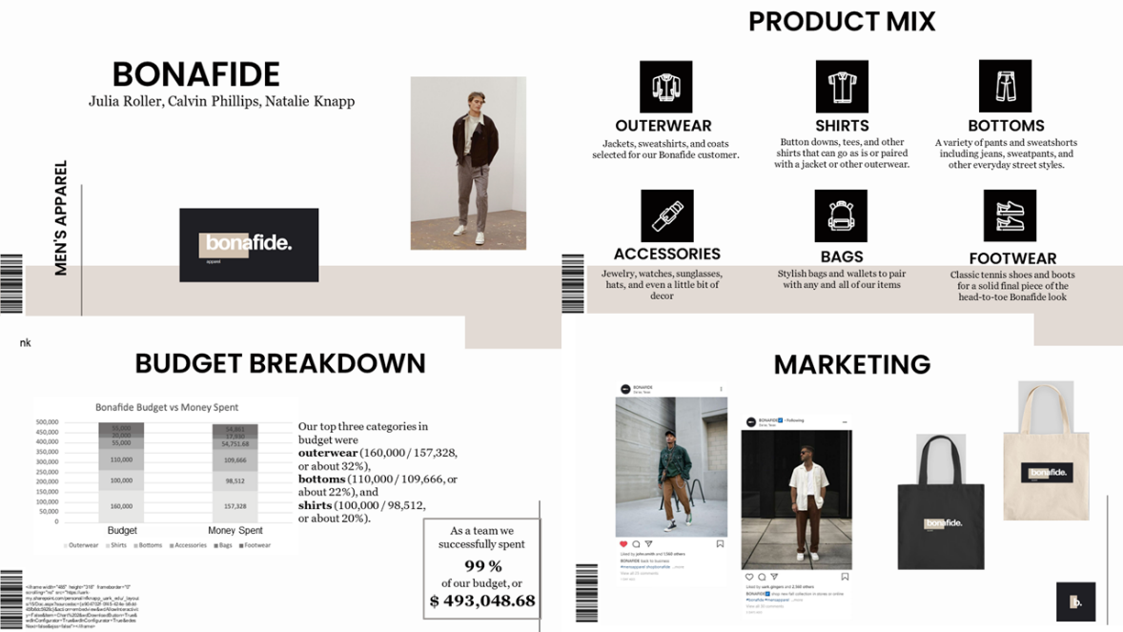
Conclusion
By gaining access to a real-world shopping environment and using the FAVES Pro software, the students could confidently curate their collection because they fully understood their orders and deliveries. Through this initiative, they were able to better comprehend the buyer and entrepreneur dynamics of the apparel industry. The students also gained knowledge of cutting-edge tools and how to use them to make intelligent purchasing choices.

References
Blaazer, E. (2023, February 9). What is the function of fashion trade shows and when do they take place? FashionUnited. Retrieved March 24, 2023, from https://fashionunited.uk/news/background/what-is-the-function-of-fashion-trade-shows-and-when-do-they-take-place/2022113066509
FAVES Pro (2021). Fashion buyer app for professional buyers. Retrieved from
https://thefavesapp.com/
Kozma, K., Meyer-Miner, A., Chio, J., Mak, S., El-Boraie, A., & Sealey, D. (2021). Developing an industry job simulation program for graduate and postdoctoral trainees in Life Sciences. Canadian Journal of Career Development, 20(2), 84–93. https://doi.org/10.53379/cjcd.2021.102

