What you wear is what I wear, Your culture is my culture
Rawabi Alharbi, King Abdulaziz University, Evon Angelina, Heriot-Watt University and Elham Maqsood, PhD, King Abdulaziz University
Keywords: Traditional costumes, Cultural Fusion, Sustainability, Fashion Design.

Contextual Review and Concept Statement: Fashion is a type of symbolic behavior that has a role in the emergence, continuity, and development of different cultures (Al-Jawhary & Shukri, 2007). The diversity in cultures results in difference aesthetic taste, depending on the traditions, geographical area, religion, and social and cultural demographics (Vargel & Ozgur, 2022). Despite the great diversity in cultures, it may appear that there are no common denominators between them. However, different cultures have common features that lie in the foundation, design, construction, and function. Upon realizing the goals each culture seeks to achieve, it can be noted that if there is commonality between different cultures, then diversity simply becomes different ways to achieve similar goals (Al-Jawhary & Shukri, 2007).
This establishes the foundation that a link can be made to merge common features between the cultures of Saudi Arabia and Scotland, which is the purpose of this design. In addition, the design preserves the original heritage and promotes the rapprochement of cultures while keeping up with the pace of the rapid development of our time. Scholars have emphasized the importance of preserving the symbolic meaning behind traditional costumes and understanding the costume as a media structure and an identity signal (Ermilova, 2020). It is a challenge for fashion designers to create something that does not use the past as a source of inspiration, reference, or a starting point. Additionally, it is rare to create a design that is not based on a known theory or technology. Therefore, inspiration from the past and the nurturing traditions are essential elements for innovation and the development of special skills and ideas to achieve success in designing sustainable fashion (Jocić, 2022).
Aesthetic properties, visual Impact, and cohesion: The design present a piece of solid value and beauty that stems from the difference in the source of each line, color, and shape. The designers overlap two different cultures in a way that each culture highlights the beauty of the other. This is a prime example of how preserving the roots from the past can help nourish our present. The design consists of an innovative piece that combines the Saudi Arabian and Scottish cultures, which is represented by the “Saudi Dagla” and the “Scottish Jacket”. This piece can be worn on formal occasions and celebrations as an outer piece that matches several types of clothing underneath. It also considers the importance of sustainability and preservation.
The design, executed in blue and black, is distinguished as the darkness of the night that envelops the entire universe and gives it tranquility. Interspersed with stripes of white, beige and gold, mimicking the colors of the galaxies and shining stars, which break the darkness of the night with brilliant and breathtaking beauty. The weaving technique was followed in the decoration of the design with ribbons of varying color and thickness to stimulate the Scottish Tartan, which are characterized by different sizes of intersecting lines. It expressed the beauty of the intertwining of various cultures. By using natural wool, a sense of belongingness to the nature was established. It honors the material that clothed our ancestors and still retains its magnificent beauty. In addition to this, the use of stone as a tool to close the uniform instead of plastic buttons has a symbolic value. The stone connects the two sides of the design tightly, such as the interdependence that this design aims for between Saudi Arabian and Scottish cultures.
Process, technique, and execution: Inspired by the distinct combination of the “Saudi Dagla” and the “Scottish Jacket”, the design exuded luxury and tradition. The design is a long ankle-length jacket that is made of a 100% natural wool and lined with 100% polyester. The long triangular sleeves were inspired by the sleeves of the “Mordoun dress”, which is usually worn below the “Saudi Dagla”. The design incorporates reusing to promote sustainable practices by collecting Fabric wastes from the students at the Department of Fashion and Textile, King Abdulaziz University. The waste used to make stripes and tassels by cutting the fabrics into different sizes stripes to imitate the Scottish tartans, which are made from differently sized crosshairs. The intersecting stripes are woven together by the invisible appliqué stitch "blind stitch" (Figure 1). The tassels were made from the leftover threads of the stripes (Figure 2), thereby avoiding any further waste. To bring everything together, a ‘rock’ was used as a substitute for a button to enhance sustainability using natural materials and to give a symbolic touch (Figure 3). This rock belonged to the Najd region in the Kingdom of Saudi Arabia.

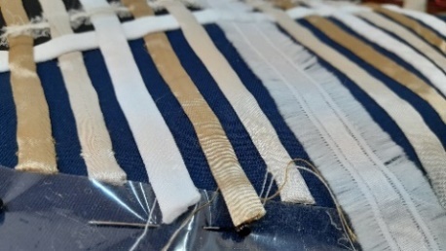 | 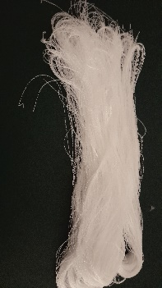 | 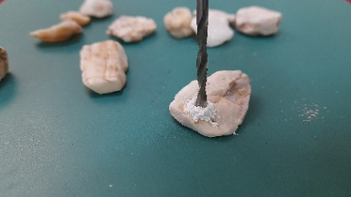
Figure 1: Creating tartan-like stripes. | Figure 2: Reusing waste to create tassels. | Figure 3: Making holes in rocks to substitute plastic buttons.
Significance, contribution, originality, and innovation: The design represent the fusion of cultures as a means of preserving and disseminating heritage, building a close connection to culture and environment while simultaneously understanding the relationship between a costume and a place. Symbolic culture includes patterns of symbols or methods of using them in relation to acquire knowledge, organizing it and transferring it to others through language or various arts (Al-Jawhary & Shukri, 2007). This includes designing costumes through which the past can be linked to the present and bringing about development in traditional culture. Heritage has a great value and significance as it represents a historical dimension capable of being developed for the future to be invented. Besides the symbolic concept of traditional fashion in different cultures, this design displays the aesthetics of modern fashion can be adapted to individual psychological and functional needs with creative interventions by producers and consumers. Improving designs in terms of sustainability using new ways to recycle different materials and employing them in creative ways to enrich fashion. This promotes sustainable design practices and presents a beautiful concept based on preserving heritage and the environment.
References
Al-Jawhary, M, & Shukri, A. (2007). Introduction to the study of anthropology. International House for Cultural Investments.
Ermilova, D. Y. (2020). Costume as a form of visualization of ethnicity: from tradition to modernity. Rupkatha Journal on Interdisciplinary Studies in Humanities, 12(6), 1-14. https://dx.doi.org/10.21659/rupkatha.v12n6.20
Jocić, S. (2022). Sustainability in fashion: Past creativity as an inspiration for the future. Tekstilna industrija, 70(2), 28-39. https://doi.org/10.5937/tekstind2202028J
Vargel, I., & Ozgur, F. F. (2022). Beauty, Aging and AntiAging. Academic Press.

