MAKE IT AUTHENTIC AND ENGAGING: CREATING AUTHENTIC RESOURCES FOR TEACHING ARABIC AND OTHER LANGUAGES

Ayman S. Elbarbary, Indiana University
Edna F. Lima, Ohio University

Numerous TAFL (Teaching Arabic as a Foreign Language) educators highlight the scarcity of materials that equip learners for real-life communication as a significant challenge (Said, 2015). Creating classroom resources from authentic sources such as YouTube videos, movies, and news articles—materials intended for native speakers—is a potential remedy (Joraboyev, 2021). These resources not only prepare learners for real-life interactions but also boost motivation (Sample, 2015). This paper offers strategies for crafting technology-enhanced, engaging materials that provide real-life context for Arabic learning. It aims to assist AFL teachers in developing authentic and semi-authentic materials that incorporate the four major language skills (reading, writing, listening, and speaking), emphasizing function, pronunciation/phonology, and grammar. While focusing on Arabic, the guidelines presented in this paper are universally applicable to any language teaching.

INTRODUCTION

Many instructors in the field of Teaching Arabic as a Foreign Language (TAFL) highlight the significant lack of resources aimed at preparing learners for successful real-life communication as a primary challenge they face (Said, 2015). While the TAFL literature addressing this issue remains limited, research in English as a Second Language (ESL) has long advocated the use of authentic materials to simulate practical language use experiences in classrooms. These materials encompass any written or audiovisual content not initially designed for pedagogical purposes (Yoneda & Valvona, 2021). Essentially, they include content designed for native speakers, such as YouTube videos, films, songs, news articles, blog posts, advertisements, flyers, menus, or cookbooks. Utilizing these resources, students learn to use language naturally and more closely mimic the fluency of native speakers.

To fully understand the need for a shift away from traditional language learning resources, the metaphor of Dr. David Bell, a Linguistics professor at Ohio University, is particularly enlightening; he compares textbooks, which provide learners with customized language akin to processed food with little to no nutritional value, to authentic materials – the real food that nourishes learners’ “communicative immune system.” This nourishment enables learners to communicate more comfortably with native speakers in the target language and better repair communicative breakdowns and misunderstandings. However, exposing learners to authentic materials can be challenging and requires thoughtful selection and presentation. Integrating technology with authentic materials allows for a more conducive learning environment for L2 speakers through a multimedia experience that engages all senses.

To achieve this, however, it is essential to implement practical technology that supports learners' skill development and aligns with the lesson's goals. This paper aims to provide language instructors with best practices for developing engaging, real-life-simulating materials for teaching Arabic to non-native speakers, addressing common challenges that teachers often face. The paper draws on several fields, including ESL and instructional technology, and guides TAFL teachers in creating authentic and semi-authentic materials that integrate the four language skills with a focus on pronunciation/phonology, grammar, and functional skills in the target language. While primarily targeting TAFL teachers, the tips and strategies provided herein can benefit a wider audience, aiding any foreign language teacher in fostering more practical skills in their students. For a discussion of AI (ChatGPT) and pronunciation instruction, see Lima and Wallace (2024, in the proceedings).

Teaching Pronunciation

Pronunciation is crucial for any language learner aiming to master communication in the target language and avoid misunderstandings. Despite its importance, pronunciation often receives insufficient attention for a variety of reasons, including lack of proper resources and nonnative teachers’ level of confidence in their ability to teach it (Murphy, 2017). However, incorporating authentic materials through technology can serve as an effective strategy to address these hurdles, providing a practical solution to enhance pronunciation instruction in language education.

Pronunciation is intrinsically linked to all other language components and skills. Listening to a variety of speakers, including those with different accents, helps learners understand that there is a range of pronunciation variations. Büyükahıska and Uyar (2019) argue that “practising listening skills based on a particular accent may cause some disadvantages for learners in the sense of linguistic skills (p. 1388); this means that exposing learners to different accents and pronunciation is crucial. Effective listening practice can improve one’s ability to mimic pronunciation, leading to more natural and comprehensible speech. Pronunciation is also interconnected with vocabulary and speaking skills; poor pronunciation can affect intelligibility, leading to misunderstandings and communication breakdowns (Levis, 2018).

Pronunciation also has cultural implications, as variations in pronunciation can alter word meanings and potentially convey unintended cultural connotations. Additionally, cultural awareness helps to improve pronunciation. Boayrid (2023) suggests that the highest level of acculturation (cultural competence) helps learners to attain a high pronunciation proficiency level. Finally, reading is also connected to pronunciation because reading out loud can enhance pronunciation by providing practice in sounding out words and phrases. In American English, for example, consistent practice with reading helps in recognizing the correspondence between written and spoken language. The following sections explore how technological tools can be utilized to enhance the teaching of pronunciation, culture, vocabulary, listening, and reading.

Pronunciation Example - Pronunciation Expert! YouGlish

One example of a resource for authentic material is Youglish.com/arabic, a web application that allows users to search for words and/or phrases in the entirety of the YouTube video database to locate video excerpts that employ the searched term(s). This revolutionizes pronunciation learning in that instructors and learners can easily and quickly find real-life uses of words and expressions spoken by native speakers. Furthermore, the words are contextualized, equipping learners to comprehend and recognize them within sequences of speech rather than in isolation. The app streamlines the process of identifying authentic materials from YouTube featuring specific vocabulary words that are both educational and engaging.

Presently, YouGlish supports many world languages including English (USA, UK, Australia, Canada, Ireland, Scotland, and New Zealand), Arabic, Chinese, Thai, German, Korean, Italian, and Japanese, and is continuously expanding to include additional languages. This not only enhances vocabulary acquisition but also enriches the learning experience by connecting learners with real-world language use.

The possible applications of YouGlish in the classroom are endless. For example, instructors can use it as a part of their flipped classroom when assigning new vocabulary sets to students to learn at home; using the program, students will be asked not only to learn a set of words, as traditional courses would have it, but rather to come to class with a sentence that they have found from YouGlish for each word. Because of the vast amount of content available on YouTube, every learner can find uses of the word in contexts that interest them and thus are far more likely to retain vocabulary and remain engaged. Figure 1 shows an example of output generated by YouGlish for the word ‘falafel.’

Figure 1
A Screenshot of the Word Falafel in Arabic from YouGlish

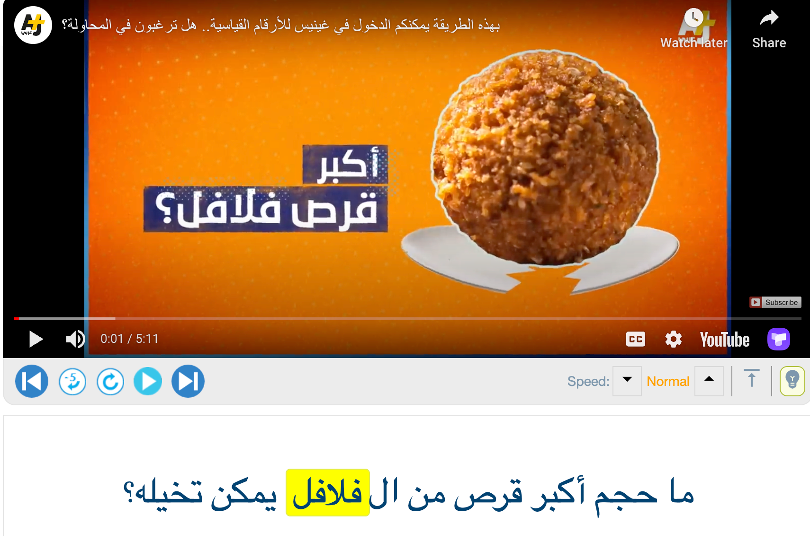

Encouraging students to present their sentences at the beginning of class provides an opportunity to encounter a range of context from their peers, fostering the practice of hearing and speaking practical, everyday language. Furthermore, engaging in vocabulary learning allows learners to more effectively notice stress and intonation patterns. This not only enhances their pronunciation but also improves their understanding of how native speakers communicate, thereby broadening their linguistic and cultural comprehension.

Teaching Culture

Teaching students the target language’s culture is essential when learning any language. McKay (2003) states that “Culture plays a significant role in language pedagogy in at least two ways. First, cultural knowledge often provides the basis for the content and topics that are used in language materials and classroom discussions. Secondly, pragmatic standards are frequently based on particular cultural models” (p. 10). That is to say, when students are exposed to the culture authentically, they are likely to learn essential language components that cannot be found in language textbooks.

While textbooks have value in the language learning journey, one criticism that can be made regarding them is that they often include content far removed from the ways native speakers communicate and live. With ever-increasing Internet interconnectivity, how instructors incorporate culture into language learning should change. Consequently, greater emphasis should be placed on more authentic activities as in the following examples.

Culture Example 1 - Speak to a Native Speaker!
This example of teaching culture can be done through a semester-long project. This project is designed to deepen learners’ understanding of the culture and community of the language they are studying. It aims to improve self-directed learning and problem-solving skills while developing the four language skills. For this project, learners may choose to work individually or in groups, although group work is recommended to foster collaboration. The project begins with learners selecting a cultural aspect, such as Arab cuisine, clothing, or traditions, and then conducting face-to-face or virtual interviews.

These interviews will be used to create a series of podcast episodes. Near the end of the semester, learners present their findings to their classmates, engage in discussions, and exchange ideas with their peers. Finally, they write a reflective paper about their experience participating in this activity, things they have learned, and considerations for future projects. Before starting the project, the instructor should provide initial scaffolding (e.g., watching YouTube videos or reading articles) and address questions or concerns to guide the project effectively. Additionally, it is important that the instructor set deadlines for each stage of the project to prevent learners from falling behind and to provide them with the appropriate feedback. Grow (1991) emphasizes that Staged Self-Directed Learning (SSDL) can actively equip students with the skills to become more self-directed and independent.

Culture Example 2 - Virtual Field Experiences (VFEs)

Teachers can significantly enrich their students' cultural exposure within the classroom through virtual field experiences (VFEs), particularly by utilizing the capabilities of ThingLink.com, as detailed by Edwards (2023). The app is a powerful tool that enables teachers to transform any image, video, or 360-degree VR shot into an interactive learning experience (Figure 2). It provides learners with immersive learning experiences where they can engage in the target language and explore the culture through full immersion in a VR setting. For instance, TAFL instructors can use 360 virtual tours of Arab historical places (e.g., old Cairo) and cultural locations (e.g., the Egyptian museum) in their lesson planning.

Figure 2
A Screenshot from ThingLink 360 Photo Library

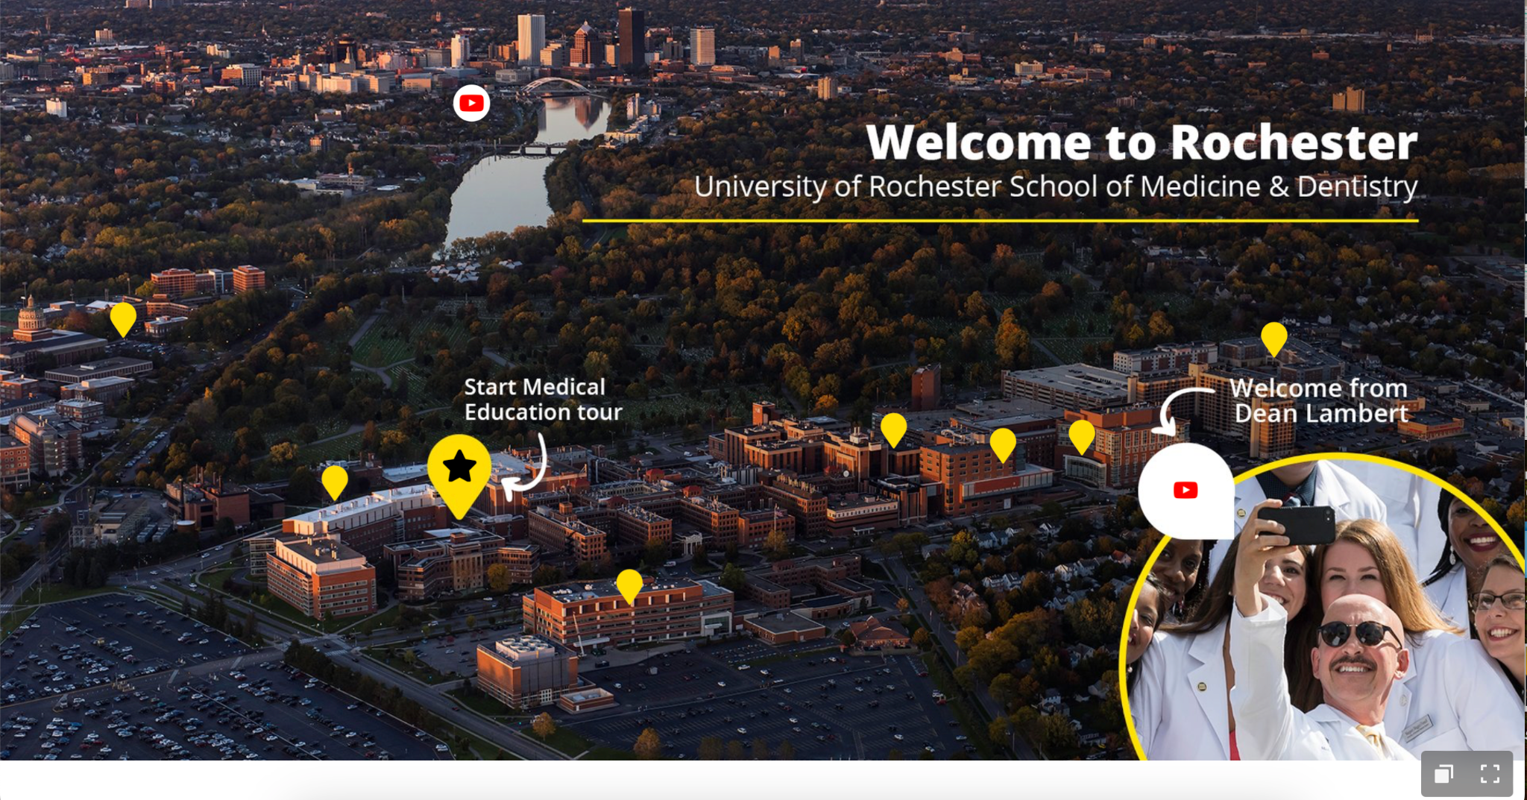

Culture Example 3 - Google Maps for Elementary-Level Learners

Google Maps Street View (Figure 3) is another application that can help students practice speaking and listening in the target language while being exposed to cultural elements. For example, it can be used with Arabic elementary learners when teaching directions to and from a given destination (e.g., a tourist attraction, an authentic restaurant, a market, etc.). First, learners are given basic dictionary vocabulary, ideally through a game. Then, in the form of a role-play, one learner asks their peers about the location of a certain place within the town or city. Following their careful directions in the target language, they must navigate the streets on Google Maps to reach the destination. Roles can then be switched, and destinations varied to enhance the learning experience. This approach trains students to give and receive directional commands and challenges them to circumlocute or repair communicational misunderstandings in real time, two vital skills for fluency development.
Figure 3
A Screenshot from Google Street View

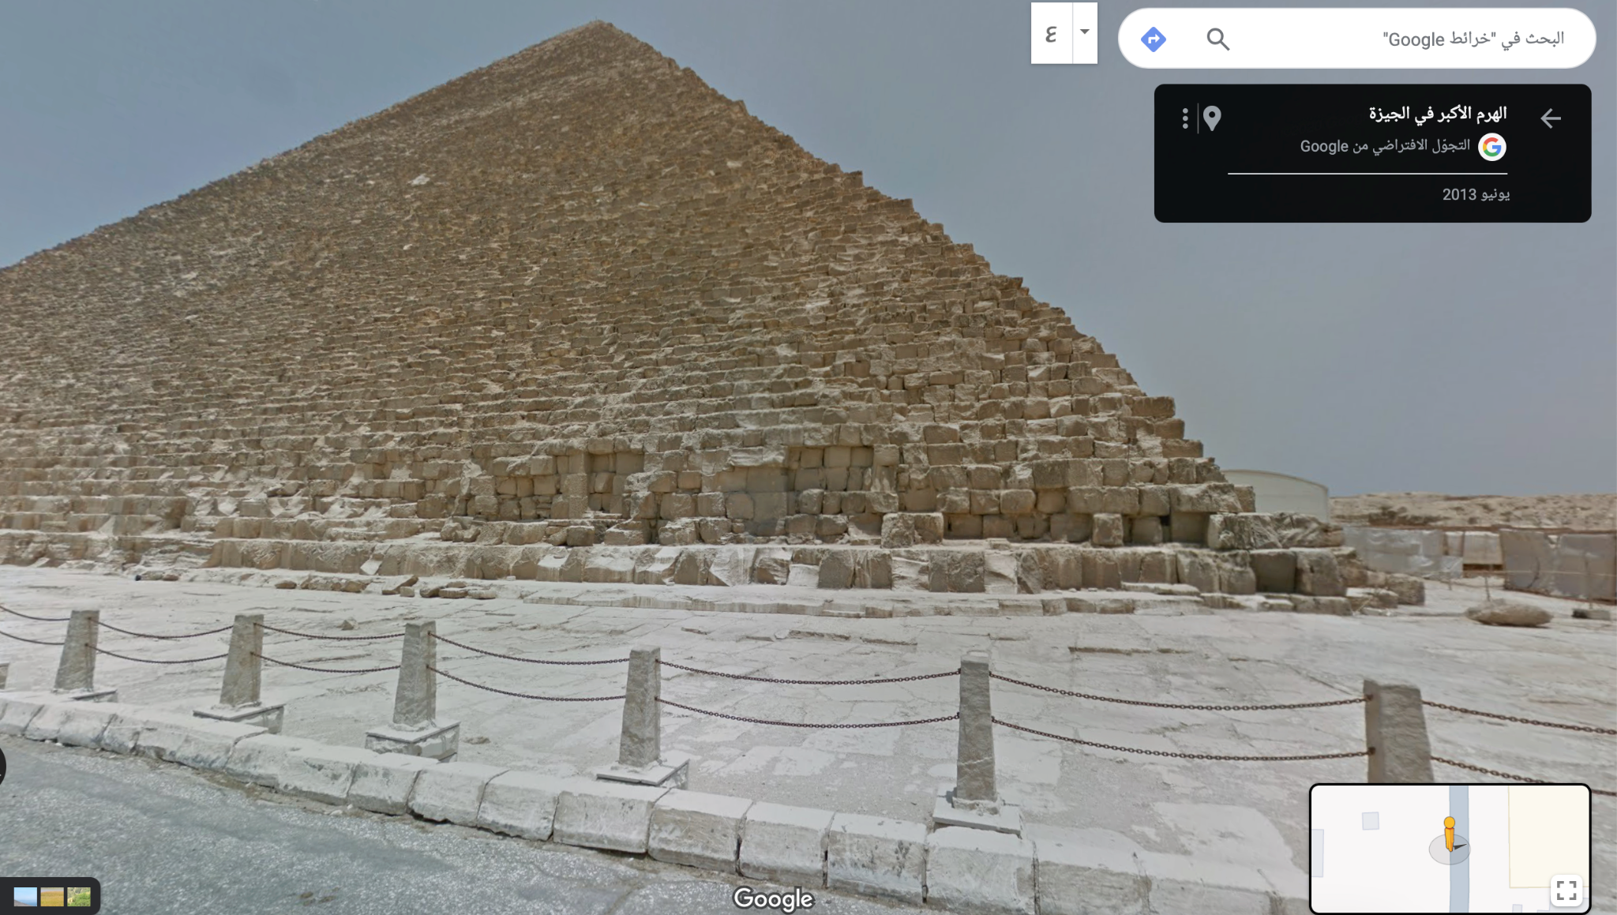

Culture Example 4 - Watch, Read, and Cook!

This is a cultural activity that incorporates the power of food and its ability to unite people. Seedhouse et al. (2020) argue that cooking in the context of language learning helps to link classroom activities to the home or, in other words, to more practical applications that have utility in the real world. Here, the aim is to enhance learners’ understanding of the Arab culture, and its cuisine. Additionally, learners’ self-learning and problem-solving skills are developed alongside the four language skills: listening, speaking, reading, and writing.

The task begins with students watching videos on a given Arabic recipe and reading about the dish’s history in the target language. Then, students learn the ingredients as well as the steps of cooking the dish. Finally, they cook the dish in groups, writing reflective papers about the experience and what they have learned from it. Writing reflections allows students to enhance their critical thinking skills and reflect on their learning. Bonk (2018) claims that one of the ways to implement an authentic environment in the classroom is by having students write reflections on assigned videos.

Teaching Vocabulary

Learning vocabulary can be one of the most tedious tasks for students in language learning, not to mention difficult for teachers to make engaging. Yet, it remains a critical component in acquiring communicative skills and, therefore, is inevitable in any curriculum. To tackle this issue, instructors can explore teaching vocabulary sets by assigning words to their students in the form of a game that can be played before coming to class. Instructors can create vocabulary games (memory, matching, etc.) on Scratch. This website requires instructors to know some basic coding skills.

However, if the instructor has no coding skills, they can still create some games on EducaPlay.com, Wordwall.net, and Play.blooket.com with simple steps. They also can use Adobe Aero to teach vocabulary using augmented reality, in which the learners scan a QR code using their cell phones and learn the vocabulary implemented in their real environment. Godwin-Jones (2016) highlights that the visual connections to the item in augmented reality help learners retain vocabulary. Figure 4 shows an example of an Arabic game on EducaPlay.

Figure 4
A Screenshot of a True or False Game on Educaplay

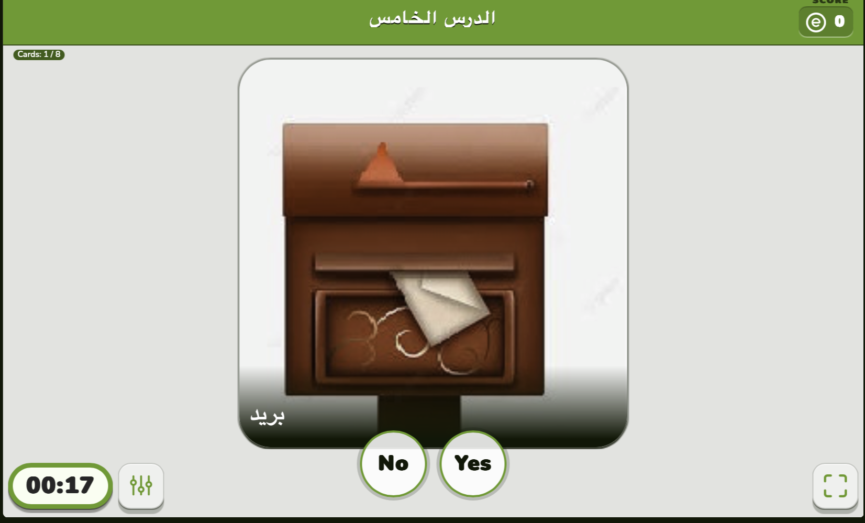

TEACHING LISTENING

Listening is a fundamental skill that learners should be exposed to early on. Instructors have a plethora of activities at their disposal to enhance their students' listening abilities. It is crucial to employ communicative language teaching (CLT) strategies that integrate listening with other skills, particularly speaking. Brown and Lee (2015) emphasize that "CLT extends beyond the merely grammatical elements of communication into the language’s social, cultural, and pragmatic features. It is an approach that encourages 'real-life' communication in the classroom" (p. 31). Engaging students in activities that combine speaking with listening is one effective way to foster a more comprehensive and practical understanding of the target language.

Listening Activity - Interactive Listening with Playposit

Teachers can create interactive listening activities using Playposit.com, a website that enables teachers to enrich their YouTube videos with various interactive activities (see Figure 5). For instance, they can add discussion forums to the videos, allowing students to reflect on their learning and interact with their peers while watching the videos. Additionally, Playposit allows instructors to add other types of activities such as pre-and-post listening questions, polls, multiple choice, and fill-in-the-blanks questions to check students' understanding. Edpuzzle and Nearpod are other tools similar to Playposit.

Figure 5
A Screenshot from Playposit

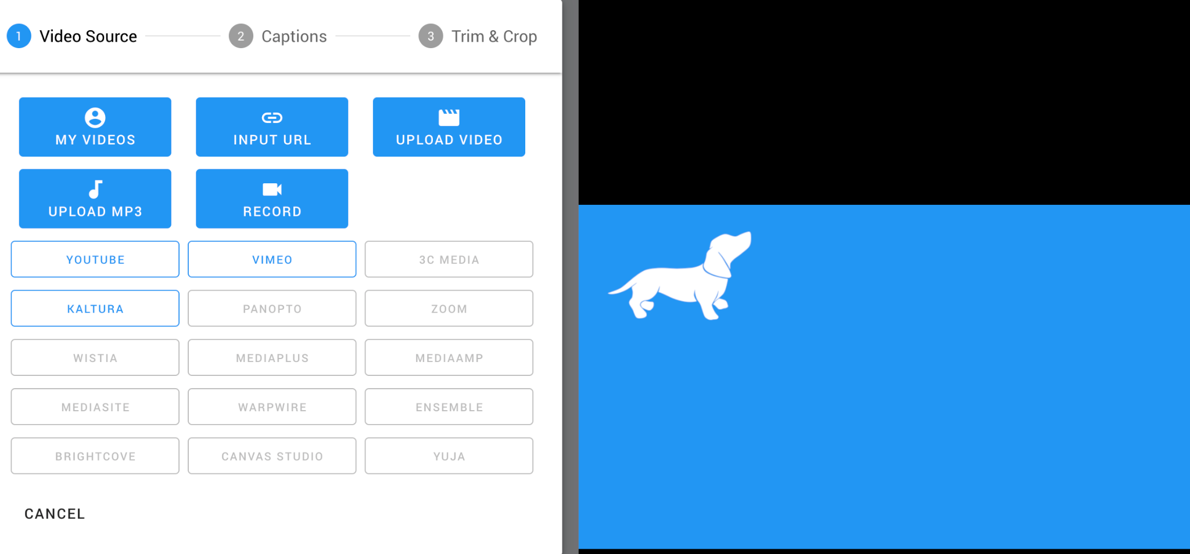

TEACHING SPEAKING

Bresnihan and MacAuley (2017), in their study with Japanese EFL learners, highlight the significance of integrating various skills along with a collaborative, interactive approach in language teaching to boost overall language acquisition. As previously noted, speaking tasks can be effectively combined with listening activities, such as using resources like YouGlish. Additionally, instructors are encouraged to design speaking activities that closely mirror real-life scenarios, ensuring the skills acquired are applicable both in and outside the classroom. With the advancement of technology, there are countless opportunities to expose learners to authentic language experiences, significantly enhancing the learning process and outcomes.

Speaking Example - Movie Night Role-play

One effective method to facilitate speaking activities is through authentic tasks suitable for asynchronous language teaching. For instance, the Movie Night role-play begins with learners convening on Zoom to plan a movie night and dinner. They visit websites suggested by the instructor to select an Arabic film and decide on a restaurant. Prior to recording their role-play on platforms like Zoom or Flip, learners have the chance to practice it. This activity not only simulates real-life interactions but also encourages creativity and practical application of language skills. It can be adapted to various contexts, such as arranging accommodations in Cairo via Airbnb or making purchases on Amazon, further broadening its applicative scope.

TEACHING READING

Teaching reading can effectively integrate other language skills, such as in the Jigsaw activity. In this approach, each learner reads a segment of a text and then recounts their portion to the group, enhancing communicative and critical thinking abilities. Furthermore, instructors can employ Inquiry-Based Learning (IBL) to encourage students to practice reading while developing their critical thinking skills. Lee (2014) notes that IBL increases student engagement and participation in language classes. It fosters "discovery, reflection, and creativity, and ignites cognitive and metacognitive skills as well, which by all means facilitate self-regulated learning and future learning transfer" (p. 1237). This method not only improves comprehension and analysis skills but also encourages a deeper, more engaged approach to language learning.

Reading Example - Make your Own Questions!

This activity follows inquiry-based learning and aims to help learners practice reading by asking them to create their own questions on a reading passage. It starts with the instructor providing learners with an authentic text (a newspaper article, a scientific article, a recipe, etc.). In groups, learners read the article and come up with some creative questions about it. They can then evaluate their questions using the artificial intelligence tool Ask SMILE at https://ask.smile.stanford.edu. This tool was developed by Dr. Paul Kim at Stanford University. The tool allows learners to evaluate their questions on a scale from one to five, following Bloom’s Taxonomy (see Figure 6). The more creative the questions, the higher the scores. Then, all groups exchange questions and try to find the answers from the text.

Figure 6
The AskSMILE Homepage for Question Evaluation

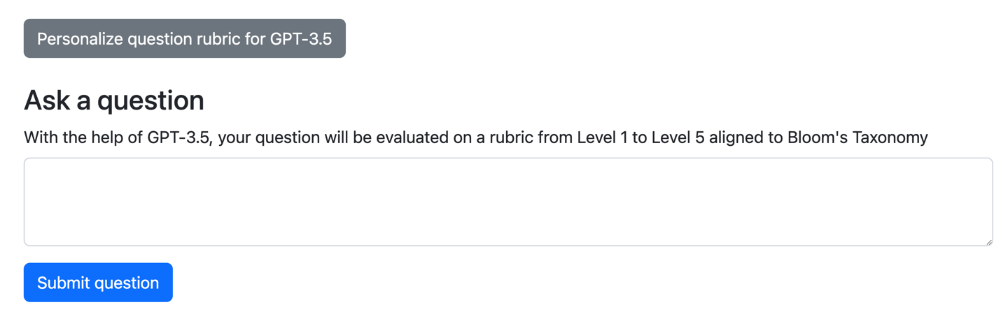

TEACHING WRITING

Instructors can enhance their learners' writing skills by employing collaborative writing techniques. Collaborative writing involves learners working together on writing tasks and providing peer feedback. This approach not only increases learners' motivation, engagement, and awareness of linguistic forms but also deepens their understanding of audience, purpose, and tone (Kessler, 2014). Tools like Padlet, Google Docs, or Microsoft Word facilitate this collaborative process, allowing learners to exchange feedback and learn from each other's mistakes.

Over the past two decades, the nature of writing has evolved significantly with technological advancements. Kern (2021) points out that today, ordinary individuals can communicate with thousands through social media, transforming writing into a form of authoring. It is crucial for language instructors to leverage these changes in digital literacies by incorporating technology into their writing activities. By doing so, they can align their teaching practices with contemporary communication trends and enhance the effectiveness of their instruction.

Writing Example 1 - Expert Writers

For this activity, the instructor provides learners with an authentic piece of writing on a topic of interest to the class. Using a Jigsaw-style activity, the instructor divides the writing among learners. Each one writes a summary of their parts and then shares their summaries with their group members on Padlet or on Google Docs. The learners then collaboratively combine their writing and create a coherent and cohesive piece. They then give feedback to each other based on a provided rubric, whose focus differs depending on what the instructor needs to assess in each task. Another activity that can be done using Padlet (see Figure 7) is to have each learner select a famous figure and write a brief description of them in the target language without revealing their identity. Their peers will then be asked to guess the character using their reading skills.

Figure 7
Character Description Activity on Padlet

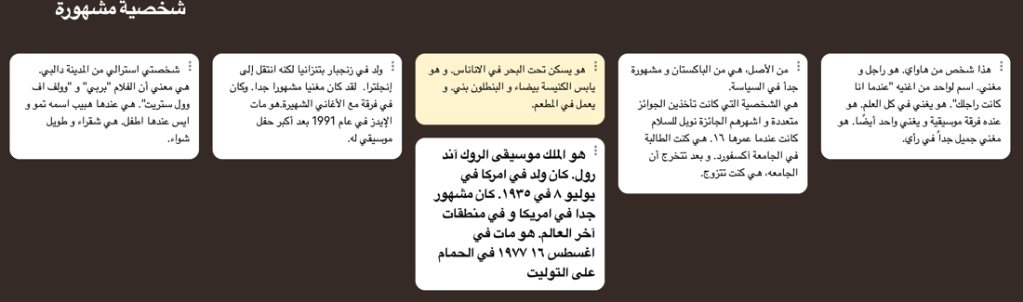

Writing Example 2 - Create Your Own Book!

This activity starts with learners choosing a topic and reading about the topic from authentic content (e.g., online articles, YouTube videos, etc.) and then creating their own books on Microsoft Sway, Storybird, Storyjumper, and bookcreator.com. The learners should be instructed to make their electronic books interactive and include photos and YouTube videos. Based on a rubric that targets the specific objectives of the activity, learners provide peer feedback on their classmates’ books.

Writing Example 3 – Comics

Various platforms enable instructors to assign creative writing activities, such as comic creation, to their learners. Tools like Pixoton Comic Maker and Adobe Express are excellent for these tasks. On Pixoton, learners can craft their characters and select settings, allowing for a personalized and engaging storytelling experience. Instructors might assign specific themes, such as sports or art, prompting learners to create comics within these contexts. This approach not only boosts engagement but also serves as an effective method for peer feedback. By transforming writing assignments into imaginative and interactive projects, learners can develop their writing skills in a dynamic and enjoyable manner, making the learning process both effective and memorable.

Writing Example 4 - Wikipedia Education

Instructors can apply to host their advanced Arabic courses on www.dashboard.wikiedu.org. The assignments for their students will contribute to Wikipedia Arabic articles. Students can write new articles, edit existing ones, or translate articles from other languages into Arabic as long as they meet the requirements and approval of Wikipedia. It is advisable that instructors host their courses on Wikipedia and submit their assignments in advance to allow enough time for the approval process.

FINAL THOUGHTS

This article has not only underscored the pivotal role of authentic materials in teaching Arabic as a foreign language (TAFL) but also illuminated a path for educators seeking to invigorate their instructional methods across various languages. The strategies and activities delineated herein serve as a beacon, guiding educators towards more dynamic, effective, and culturally rich teaching practices. By integrating authentic materials and leveraging technology, educators are equipped to offer students a more engaging, relevant, and comprehensive learning experience. This approach not only enhances linguistic proficiency but also deepens cultural understanding, preparing students to navigate and appreciate the rich tapestry of the target language's community and heritage. The potential of such methods extends beyond the immediate classroom, promising to foster a generation of learners who are more communicative, culturally aware, and prepared for the global stage.

ACKNOWLEDGMENTS

The authors thank the creators of the course Transforming the Teaching of Language Online (TTLO) at ​​the Center for Advanced Research on Language Acquisition (CARLA) at the University of Minnesota for introducing the Playposit, EdPuzzle, and movie night role-play activities. Additionally, we thank the Center for Educational Resources in Culture, Language, and Literacy (CERCLL) at the University of Arizona for introducing us to the Virtual Field Experiences (VFEs) activity while participating in the Worlds of Experience (WELL) project. Finally, we thank Yuru Zhu and Bao Quoc Hoang for introducing the Pixoton and WordWall apps.

ABOUT THE AUTHORS

Ayman Elbarbary is an associate instructor at Indiana University. He holds an M.A. degree in Applied Linguistics from Ohio University and has been a Fulbright Foreign Language Teaching Assistant at the University of North Georgia. He taught Arabic at Ohio University and English at the American University in Cairo and Ahram Canadian University. Ayman is a double-major Ph.D. student in the Instructional Systems Technology and Middle Eastern Languages and Cultures departments at Indiana University.

Contact Information:
Middle Eastern Languages and Cultures Department
Hamilton Lugar School of Global and International Studies
355 N Eagleson Ave,
Bloomington, IN 47405
aelbarba@iu.edu

Dr. Edna Lima is an Associate Professor of Instruction and Director of Instructional Design & Global Outreach Online Programs at Ohio University, where she teaches CALL, language assessment, second language acquisition, and writing for research and publication. She is also developer, manager, and instructor of the English as a Medium of Instruction (EMI) course, a grant sponsored by the U.S. State Department and administered by FHI 360. Dr. Lima earned her Ph.D. in Applied Linguistics & Technology from Iowa State University. Her research interests include CALL, EMI, language assessment, online courses and materials design, and writing for research.

Contact information:
383 Gordy Hall
Athens, OH 45701
lima@ohio.edu

REFERENCES

Boayrid, N. F. (2023). Cultural competence in L2 pronunciation acquisition. International
Journal of Linguistics, 15(2), 119-139.
Bonk, C. J. (2018). Tapping into history via video: Enlisting the legends and legacies of our field. TechTrends, 62(6), 538-540. DOI:1007/s11528-018-0332-3
Bresnihan, B. D., & MacAuley, M. (2017). Students' perceptions of the benefits of integrated-skills language classes. 人文論集, 52, 1-19.
Brown, H. D., & Lee, H. (2015). Teaching by principles: An interactive approach to language​ pedagogy (4th ed.). Pearson Education.​
Büyükahıska, D., & Uyar, A. C. (2019). The effects of different accents on listening comprehension in EFL classes. OPUS Uluslararası Toplum Araştırmaları Dergisi-International Journal of Society Researches, 14(20), 1370-1394. https://doi.org/10.26466/opus.610859
Edwards, L. (2023, November 27). ThingLink: How to use it to teach. Techlearning.com. https://www.techlearning.com/how-to/what-is-thinglink-and-how-does-it-work
Godwin-Jones, R. (2016). Augmented reality and language learning: From annotated vocabulary to place-based mobile games. Language Learning & Technology 20(3), 9–19.
Grow, G. O. (1991). Teaching learners to be self-directed. Adult Education Quarterly, 41(3), 125-149.
Joraboyev, B. B. O. (2021). Using authentic materials on English lessons. Academic Research in​ Educational Sciences, 2(2), 1018-1025. DOI: 10.24411/2181-1385-2021-00295.
Kern, R. (2021). Twenty-five years of digital literacies in CALL. Language Learning & Technology, 25(3), 132–150. http://hdl.handle.net/10125/73453
Kessler, G. (2014). Social media and writing in a second language. Intercom: University of Oregon. Online at: http://caslsintercom.uoregon.edu/content/18083
Lee, H.-Y. (2014). Inquiry-based teaching in second and foreign language pedagogy. Journal of Language Teaching and Research, 5(6), 1236-1244. https://doi.org/10.4304/jltr.5.6.1236-1244
Levis, J. M. (2018). Intelligibility, oral communication, and the teaching of pronunciation. Cambridge University Press.
McKay, S. L. (2003). Toward an appropriate EIL pedagogy: Re-examining common ELT assumptions. International Journal of Applied Linguistics, 13(1), 1-22.
Murphy, J. (2017). Introduction and background to pronunciation teaching. In J. Murphy (Ed.), Teaching the pronunciation of English: Focus on whole courses. University of Michigan Press. https://doi.org/10.3998/mpub.8307407
Said, F. (2015, September 8). It is not enough to modernize Arabic teaching materials- their​ content matters too. Category Archives: Arabic Learning & Teaching.​https://arabizi.wordpress.com/category/arabic-learning-teaching-materials/ ​
Sample, M. G. (2015). Authentic materials: A motivational tool for the EFL classroom.​Education and Linguistics Research, 1(2), 100-119. http://dx.doi.org/10.5296/elr.v1i2.8488
Seedhouse, P., Heslop, P., & Kharrufa, A. (2020). Cooking as a language learning task. The Electronic Journal for English as a Second Language, 24(1), 1–13.
Yoneda, M., & Valvona, C. (2021). Authentic materials: Definitions, perception, and usage by ELT practitioners. Bulletin of School Education Center, 6, 76-91.

